LANDSCAPING INTERNATIONAL LONGITUDINAL DATASETS

FULL REPORT
JULY 2023

Funded by The Wellcome Trust

With contributions from the Institute of Psychiatry, Psychology and Neuroscience at King's College London, MQ Mental Health Research and the Open Data Institute

This report was prepared as part of a project undertaken in response to a Request for Proposals (RfP) from the Wellcome Trust. The call was to undertake a landscaping activity of opportunities afforded by the most promising large scale longitudinal datasets globally to advance scientific understanding of how brain, body and environment interact in the trajectory and resolution of anxiety, depression and psychosis.
This report was written by researchers at the Institute of Psychiatry, Psychology and Neuroscience at King's College London with contributions from MQ Mental Health Research, the Open Data Institute and the Wellcome Trust Lived Experience Advisory.

contents
Introduction 5
Foreword 5
Executive summary 6
Contributors 9
Background 11
Introduction to the project 11
Description of the project 12
The partnership 13
Methods 14
Landscaping process 14
Transparency as integral to the process of landscaping 17
Engagement with community and LEE involvement 17
Theory of Change (ToC) process 19
Results
Worldwide longitudinal data landscape 22
Regional breakdown 25
Pockets of value 29
1. Richness in mental health measures 33
2. Value in targeted populations 39
3. Diversity of data 44
4. Mental health embedded in wider context 51
Enrichment for the selected longitudinal datasets 56
Identifying datasets meeting the selection criteria 56
1. Preserve and expand targeted populations 57
2. Improve measurement and collect new data 59
3. Build infrastructure and facilitate connectivity 62
4. Promote LEE involvement, community engagement and service users’ input 63
Conclusion 65
Concluding remarks 65
Acknowledgements 69
Glossary 70
References 72
Appendix: List of selected longitudinal datasets 81

Introduction

Foreword

By Professor Miranda Wolpert MBE
Director of Mental Health, The Wellcome Trust

This is a milestone publication. Longitudinal datasets serve as a vital resource for researchers, providing invaluable insights into the complex interplay between the brain, body and environment in the trajectory and resolution of mental health problems.
When Wellcome commissioned King’s College London, MQ Mental Health Research and the Open Data Institute to identify and gather information on promising longitudinal datasets from around the world we did not know exactly what they would find.
The results of this important endeavour reveal the breadth of existing data that can be used for mental health research- the report identifies over 3,000 longitudinal datasets spanning 146 different countries.
This work underscores the immense potential for researchers and funders to harness the power of longitudinal research to deepen our understanding of depression, anxiety and psychosis.
I would like to extend my thanks to the whole team for their fantastic work and look forward to drawing on their conclusions to help shape initiatives by funders and others to help build on and use these data to unlock greater understanding of the complex interplay of biological, psychological and social mechanisms in the development and resolution of mental health problems.

Executive summary
Longitudinal datasets are an indispensable resource for conducting research to advance the understanding of how brain, body and environment interact in the trajectory and resolution of mental health conditions. To achieve their vision of a world where no one is held back by mental illness, Wellcome commissioned a global mapping of large-scale longitudinal datasets in September 2022. The objective was to encourage their use by mental health researchers, to consider opportunities for enrichment and ultimately to create transformative research on depression, anxiety and psychosis.

The scope of this project was four-fold. First, to search for and identify longitudinal datasets across the world and across sectors, on mental health or any other topics. Second, to describe richness across all identified longitudinal datasets. Third, to review ongoing studies with large sample sizes, granular assessments and mental health data collected (or which could be collected) with participants aged between 14 and 30 years, and furthermore, to present areas that could be enriched via new data collection or recruitment of participants.

We created a partnership of academic institutions (King’s College London), charities (MQ Mental Health Research), non-profit organisations (the Open Data Institute) and lived experience expert (LEE) groups to complete this project. We worked with a range of national and international collaborators.

Input from various stakeholders was gathered as part of a Theory of Change (ToC) process throughout the project. This activity allowed us to get the views of a wider group, and especially LEEs, on the current state of mental health research and the barriers and challenges that need to be addressed in the context of using longitudinal data to enhance mental health outcomes. Most importantly, this process guided the scoping for richness in longitudinal datasets and the assessment of areas of enrichment.

We identified 3,068 longitudinal datasets worldwide; 25% from the Americas, 25% from Africa, the Middle East & Asia, 46% from Europe & the Pacific, and 4% cross-regions. These datasets covered 146 different countries. Countries without longitudinal datasets were mostly small Low- and Middle-Income Countries (LMICs).

We found richness for mental health research in several longitudinal datasets that we organised into 19 groups or ‘pockets of value’. These pockets were then clustered into four categories:
- Richness in mental health measures including strong measurement of depression and anxiety, valuable resources for psychosis research, other mental health conditions, and mental health across the life course.
- Value in targeted populations including high-risk groups, under-represented groups, populations from under-represented locations, ageing populations, and value in the long run.
- Diversity of data including factors contributing to mental health conditions, neuroimaging data, wearables and phone apps, biological and genetic data, and routinely collected data.
- Mental health embedded in wider context including mental health within social context, the impact of the Coronavirus disease (COVID-19) pandemic, connectivity between datasets, natural disasters and geopolitical factors, and interventions embedded in longitudinal datasets.

We found that each geographical location often provided specific value such as routinely collected data in Europe, long standing cohorts in the Americas and datasets embedded in social context in Africa.
The review also indicated a dearth of ongoing studies with large sample sizes, granular assessments and mental health data when participants are between 14 and 30 years: only 100 of the longitudinal datasets we identified (3%) met these criteria for further consideration and of those, only 10% primarily focused on mental health.

A review of those 100 longitudinal studies revealed possibilities for enhancing the value of those important data resources. We reported opportunities for enrichment covering four areas:
- Preservation and expansion of targeted populations with supporting retention to maintain representativeness of the data, diversifying recruitment and improving retention of minoritised and marginalised participants, and expanding targeted population of existing samples.
- Improvement of measurement and collection of new data with supporting methodological work to test the comparability of mental health data for already collected measures in childhood, assessing mental health conditions across diagnostic categories, harmonising mental health measures to facilitate international comparison and discover the importance of social/cultural context, introducing regular assessment of early symptoms of psychosis via self-reports, collecting qualitative and climate change data, and considering neuroimaging data to test the effect of interventions.
- Build infrastructure and facilitate connectivity with erecting infrastructure to ensure datasets include important data related to mental health, augmenting the discoverability and management of some datasets, and developing connectivity between longitudinal datasets and with other data resources.
- Promotion of LEE involvement, community engagement and service users’ input. We collaborated with LEEs to elaborate a model for enriching longitudinal datasets that are described in a separate report from MQ.
Our global search for longitudinal datasets and in-depth analysis of their potential for mental research revealed great opportunities for researchers and funders to build knowledge that can improve our understanding of depression, anxiety and psychosis. A coordinated approach to funding longitudinal research and a resolute will to improve the discoverability of existing datasets will maximise the financial, time and resource investment made thus far.

Contributors

Louise Arseneault
Principal Investigator
Louise is Professor of Developmental Psychology at King’s College London & Lead of Discoverable Data at DATAMIND
Mariana Bolivar
Facilitated the delivery & discussions of the Theory of Change workshop
Mariana is Mental Health & Inequality Programme Lead at MQ Mental Health Research
Bridget Bryan
Oversaw landscaping stages & review of non-academic datasets
PhD Candidate & Research Assistant at King’s College London
Thomas Canning
Reviewed non-academic datasets
Thomas is a PhD Candidate & Research Assistant at King’s College London
Ed Evans
Responsible for landscaping non-academic datasets
Ed is a Senior Consultant at the Open Data Institute
Grace Gatera
Contributed to the Organisation of the Theory of Change workshop & provided feedback throughout the project
Grace is a member of the Wellcome Lived Experience Expert Group
Parisa Mansoori
Responsible for the organisation of the Theory of Change workshop
Parisa is Research Lead at MQ Mental Health Research
Lea Milligan
Responsible for organising & delivering the Theory of Change workshop
Lea is CEO of MQ Mental Health Research & Lead of Capacity Building at DATAMIND
Malaika Okundi
Responsible for landscaping datasets from Africa, the Middle East & Asia
Malaika is a Research Assistant at King’s College London
Alice Stephens
Responsible for landscaping datasets from Europe & the Pacific
Alice is a Research Assistant at King’s College London
Elena Triantafillopoulou
Responsible for landscaping datasets from the Americas
Elena is a Research Assistant at King’s College London & Project Manager for DATAMIND
David Warrell
Responsible for landscaping non-academic datasets
David is a Research Associate at the Open Data Institute
Daniel Yu
Responsible for extracting datasets from repositories & monitoring submissions
Daniel is an Undergraduate Research Assistant at King’s College London

Background

Introduction to the project
In 2020, Wellcome announced its new 30-year strategy to tackle three global health challenges: mental health, infectious disease and the impact of climate change on health. For mental health, the vision is a world where no one is held back by mental health illness. To advance this vision, Wellcome is seeking to create a step change in early intervention in anxiety, depression and psychosis and has committed funding to support researchers achieving this ambitious goal (Wolpert et al., 2023).

While our knowledge about the development of mental health conditions has been steadily increasing over recent decades, this has failed to curb the rise in the number of people living with mental health conditions. In the United Kingdom (UK), approximately 18% of children aged 7 to 16 years were identified as having a ‘probable’ mental health condition in 2022, an increase from 12.1% in 2017 (NHS Digital, 2022). This figure rises to 25.7% amongst youth aged between 17 and 19. Whilst current predictions indicate that by 2030 depression will be the leading cause of disease burden globally (World Health Assembly, 2012), this is likely an underestimate, and reflected in the vast economic impacts of ill mental health of more than $4.7 trillion per year (Arias et al., 2022). The onset of first mental health conditions tends to occur before age 25 in more than half of individuals worldwide (62.5%) (Solmi et al., 2022). Conducting research to better understand the onset, development and recurrence of conditions such as depression, anxiety and psychosis is essential for finding rapid and efficient ways to predict, inform policy, intervene and ultimately stop the harmful outcomes of mental health conditions on people’s lives.

Insightful questions and reliable data are the foundation of transformative mental health research. While we have developed sophisticated tools for conducting research to match recent scientific advances, one tool that has stood the test of time is longitudinal studies. CLOSER, the home of longitudinal studies in the UK, defines a longitudinal study as an observational investigation that follows the same group of individuals repeatedly over time, sometimes from birth to mortality. Longitudinal studies are a powerful research tool that have generated a wealth of valuable data for researchers who have produced evidence that informs how to predict, identify and intervene as early as possible in these conditions. However, longitudinal studies require considerable support and commitment from funders: they are indeed expensive to set up and to maintain (Joshi, 2016; Rutter, 1994).

When initiated, longitudinal studies must have a long-term vision and offer value for money. However, their outreach and impact may be curtailed for several reasons, for example, they may be hard to find and their data may be difficult to access. They can also be overlooked by researchers seeking to collect their ‘own’ data and frowned upon because their methods are not cutting edge anymore. As a result, longitudinal datasets have often been underused despite the considerable investment they represent and the research opportunities they offer. Another source of longitudinal data that does not require large investment are routinely collected data registries. Many countries collect electronic health records that can be used for research utilising vast numbers of participants. These can be difficult to access, however.

A global search for longitudinal datasets across the world will offer a springboard for developing new and innovative mental health research while harnessing existing data resources. An overview of these datasets will provide an estimation of their richness along with a consideration for areas that would require enrichment.

Description of the project
Wellcome is interested in identifying existing longitudinal datasets, and exploring their value, with the aim of finding new and improved ways to predict, identify and intervene as early as possible in ways that reflect the priorities and needs of those who experience mental health conditions (see Request for Proposals). In the spring of 2022, Wellcome commissioned a global search for existing longitudinal datasets to advance scientific understanding of how the brain, body and environment interact in influencing the course of depression, anxiety and psychosis. We took up this huge and exciting challenge.

Further to its objective, the search had to 1) be worldwide; 2) cover datasets focused on mental health or other research topics; 3) exclude study designs such as cross-sectional studies and clinical trials; and 4) include datasets from all languages (although the data holders need to be able to communicate in English). The analysis of the datasets focused on three mental health conditions, depression, anxiety and psychosis, but these were broadly defined to also include obsessive-compulsive disorder (OCD), post-traumatic stress disorder (PTSD), schizophrenia and bipolar disorder.

This project called for a group of experts who could undertake a broad search for and an in-depth analysis of existing data sources across the world within a limited time frame. We developed a partnership that could deliver breadth, depth and speed.

The partnership
We created a partnership of academic institutions, charities, non-profit organisations and groups of people with lived experience (LE) to combine subject matter knowledge and LE expertise to deliver the outputs.

- King’s College London (KCL), the Institute of Psychiatry, Psychology and Neuroscience (IoPPN) is at the forefront of mental health care, redefining mental illness, its treatment and its place in society. This world-class institution aims to transform care for people affected by mental health and neurological conditions through impactful research, education and training and to serve our communities locally and globally.

- Open Data Institute (ODI) is a non-profit company founded in 2012 that works with companies and governments to build an open, trustworthy data ecosystem. Its mission is to create a world where data works for everyone.

- MQ Mental Health Research (MQ) is an international mental health research charity whose aim is to create a world where mental illnesses are understood, effectively treated and one day made preventable. It champions and funds world-class research to transform the lives of everyone affected by a mental health condition.

Throughout the project, we worked closely with a set of key collaborators/consultants:

- Centre for Global Mental Health (CGMH) works to address inequities by closing the care gap and reducing human rights abuses experienced by people living with mental, neurological and substance use conditions, particularly in low-resource settings.
- DATAMIND is the Health Data Research Hub for Mental Health, funded by the Medical Research Council (MRC) and Health Data Research (HDR) UK. DATAMIND is making the best use of the UK’s rich mental health data by enabling coordinated research with the ultimate aim of improving people’s lives.

- Wellcome’s Lived Experience team works to make sure the expertise of people with lived experience shapes the work Wellcome do and the programmes they fund.

Methods

Landscaping process
We divided the work for this project into six stages (Figure 1). The stages overlapped with one another once started and continued throughout the project. The breadth of our search is exemplified in the early stages of our work. The depth of our analyses is illustrated in the later stages.

Stage 1 – Searching for datasets and identifying longitudinal datasets
For datasets in academia, the KCL team adopted two different approaches to search for and identify longitudinal datasets. First, an active search which involved looking through repositories containing information about multiple datasets, such as academic journals and global consortia. Second, a passive search which involved receiving information from individuals across the world in the mental health and epidemiology communities regarding datasets and repositories.

For datasets outside of academia, the ODI team engaged in three complementary approaches. First, approaching industry contacts identified by the ODI and KCL to identify relevant datasets and discuss barriers to sharing non-academic data. Second, searching open data portals using an automated strategy. Third, using desk research to focus on the most promising types of non-academic datasets previously identified.

MQ led the organisation of a Theory of Change (ToC) process with a range of stakeholders, including Lived Experience Experts (LEEs), to inform the identification of richness and areas of enrichment for longitudinal datasets. Using the insights from this process, and priorities established by Wellcome, we evaluated the current global state of the existing longitudinal dataset landscape.

Stage 2 – Scoping for richness in longitudinal datasets
We reviewed all identified longitudinal datasets and highlighted richness in several of them. We described this richness by grouping a subset into various ‘pockets of value’.

Stage 3 – Screening longitudinal datasets according to selection criteria
The screening stage was an objective selection process based on criteria proposed by Wellcome and involved screening all identified longitudinal datasets using the following inclusion criteria:
- Consists of at least 8,000 participants at inception.
- Includes, or has the potential to include, data on participants at some point between the ages of 14 and 30, as this is the age when mental health conditions often are first identified.
- Has collected some data annually, or at least every three years, and/or can contact participants to invite more intense data collection.
- Has collected data in the last three years, has plans to collect new data or is in contact with participants.

As we were focused on the potential for collecting mental health data, datasets did not have to have already collected mental health data

Stage 4 – Reviewing selected longitudinal datasets for enrichment
The datasets meeting the selection criteria at Stage 3 were reviewed in more depth by the KCL team using information available online, such as on study websites and published cohort profile papers. A holistic approach was adopted for evaluating these remaining datasets and was based on additional factors including attrition rates, representativeness, data access and mental health measures. This approach was more subjective than the previous stage.

Stage 5 – Assessing areas of enrichment for longitudinal datasets
We assessed how the selected datasets could be enriched to maximise their potential to answer questions about depression, anxiety and psychosis. We identified areas of enrichment for the selected longitudinal datasets guided by three key elements: (1) the list of areas of enrichment provided by Wellcome’s RfP; (2) the outcomes of the ToC process capturing suggestions from different stakeholders, particularly LEEs; and (3) our experience of screening and reviewing more than 3,000 longitudinal datasets from around the world.

Stage 6 – Reporting findings
We summarised the findings of the landscaping project, including considerations for potential enrichment and the richness of datasets in this report.

Throughout the project, we used various methods to engage with mental health and broader communities, and especially via the ToC process which informed the scoping for richness in datasets and the assessment for areas of enrichment.

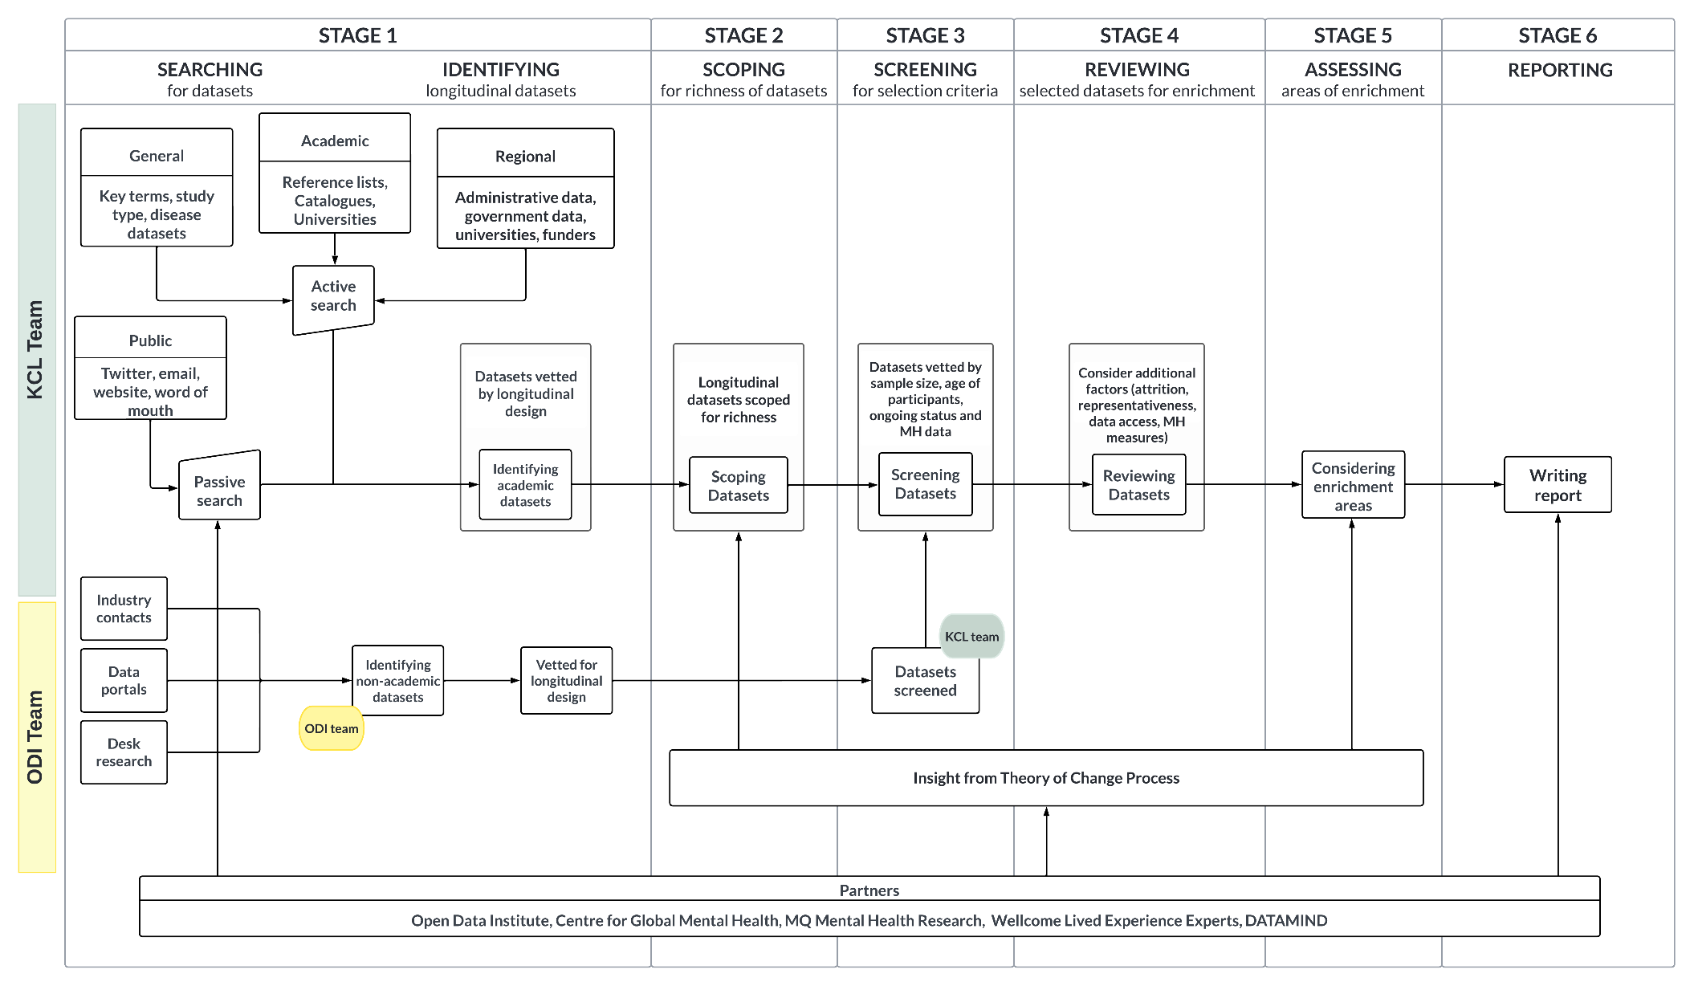
Figure 1. Flowchart describing the six stages for landscaping longitudinal datasets worldwide

Transparency as integral to the process of landscaping
Transparency was important throughout the project to ensure we were working in an open, honest and straightforward way with members of the partnership, research communities and the public.

Within the partnership, the KCL team worked on a shared drive while all partners had viewing access. We met regularly to provide updates and make group decisions. The principal investigator (PI) of the project met fortnightly with Wellcome staff to discuss progress, any concerns or gaps and next steps.

With the public, we disseminated updates and calls for submissions via a website, blog posts, social media posts and meetings. This contributed to raise awareness about the project and ensure research teams could put forward longitudinal datasets to be included in the project.

We created a website to support transparency and engagement (landscaping-longitudinal-research.com). This platform allowed the public to meet the partnership, view the longitudinal datasets identified to date on a searchable dashboard, submit datasets by completing an online form and read our blog posts. To improve accessibility to the information about our project, the website was translated into five of the most spoken research languages (French, Spanish, Portuguese, Chinese and Arabic). We posted updates and calls for submission on social media platforms (i.e., Twitter and LinkedIn), with some posts translated into different languages to increase outreach and accessibility. Whenever members of the public had questions about the project, members of the partnership met with them online or in person to further explain the project’s rationale and aims.

Engagement with community and LEE involvement
We committed to engage with research communities and the public from the start of the project.

The Landscaping website was an efficient way to engage with people outside the partnership and share information. We recorded over 5,400 visits and more than 7,800 page views from people based in 84 different countries (Figure 2). We displayed updates of the identified datasets via a searchable and user-friendly dashboard, and we disseminated our observations via nine blog posts.

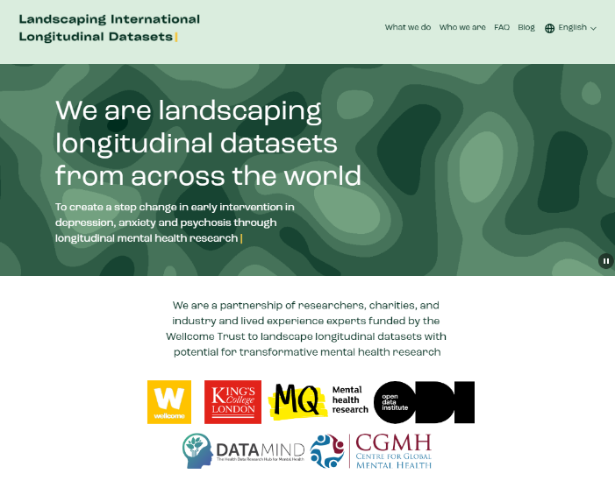 | 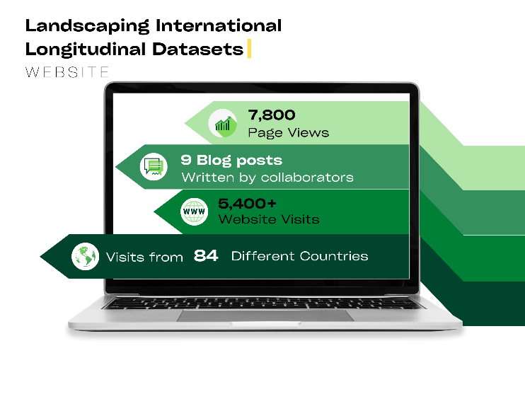
Figure 2. Summary statistics for engagement via the Landscaping website

We posted about the project, the website and the blogs on social media platforms twice per week (Figure 3). This was especially important during the early stages of the project for engaging with the community outside the partnership. It enabled us to communicate further with people who liked, shared or commented on our posts via subsequent individual emails or meetings.

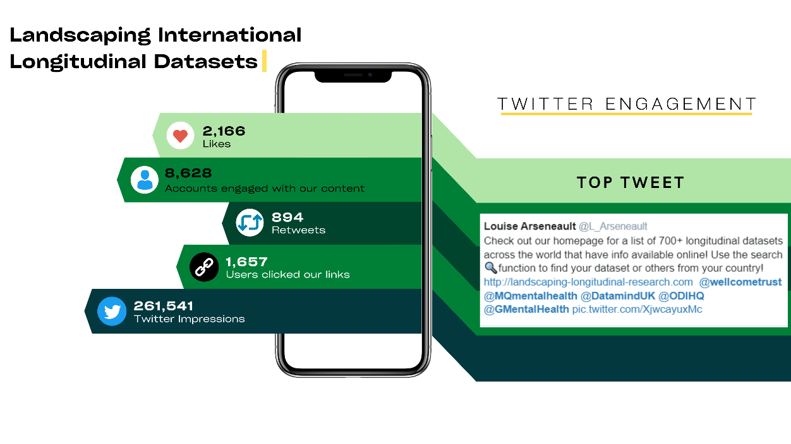
Figure 3. Summary statistics for engagement via Twitter

We met with various stakeholders within and beyond the partnership to answer their questions and encourage them to contribute information about datasets. Moreover, we engaged and collaborated closely with LEEs from Wellcome, MQ and DATAMIND throughout the project. Their contribution is exemplified during regular meetings, in our series of blogs and in the ToC process.

Theory of Change (ToC) process
MQ led on the delivery of a ToC process (De Silva et al., 2014; Breuer et al., 2014, 2016) to frame the model needed to impact mental health outcomes (see full report from MQ). The outcomes were originally defined by Wellcome and refined using the baseline findings of landscaping, while part of the model was centred around how longitudinal datasets could be enriched for mental health research. To develop a ToC model that incorporates the perspectives of all mental health research stakeholders, a co-production methodology was adopted, with the inclusion of individuals with LE of mental health conditions, as well as researchers, policymakers and other stakeholders, including those in LMICs. Their input was captured through a pre-workshop package, an online workshop discussion and a post-workshop meeting. The entire ToC process occurred alongside the landscaping process to allow the findings and insights from each process to inform the other.

Pre-workshop material: The process began with a series of submissions to the pre-workshop package, where 38 stakeholders were asked to submit their perspectives on (1) the current state of mental health research, and (2) the barriers and challenges in using longitudinal data to enhance mental health outcomes. Twenty-six stakeholders responded and this information was then used to inform the design of the workshop which was structured to facilitate open and inclusive dialogue (Figure 4).

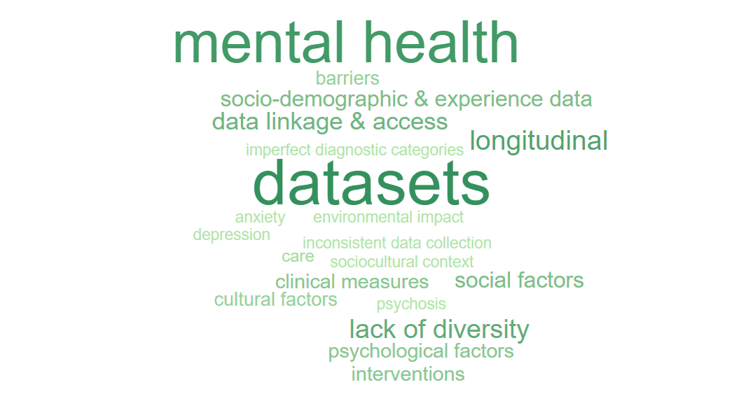
Figure 4. Word cloud of the most frequently used terms in responses to the Theory of Change pre-workshop package
Online workshop: The online workshop on 12th January 2023 brought together 31 key stakeholders, such as researchers, policymakers, practitioners and seven LEEs, from seven countries, including several LMICs. During the workshop, participants worked together to identify the key drivers of change and the intermediate outcomes that need to be achieved to bring about improvements in mental health outcomes. The discussion was framed around the development and use of longitudinal datasets for global mental health research, draft impact statements and long-term outcomes, and ways in which they could be achieved. The outcome of this co-produced ToC process was a visualisation and understanding that can be used to guide future research and impact efforts. Both are grounded in the perspectives and needs of the mental health community.

The workshop identified a range of domains where action will be required to create a global network of mental health-enabled longitudinal datasets. In addition, it suggested additional domains where action is required to ensure that longitudinal data collection drives forward changes in policy and practice to enhance mental health outcomes.

Based on the pre-submissions and workshop discussions, the ToC model was developed, distinguishing the desired long-term impact as well as intermediary goals, including the following areas of enrichment in existing longitudinal datasets:
- Preserve and expand targeted populations
- Improve measurement and collect new data
- Build infrastructure and facilitate connectivity
- Promote LEE involvement, community engagement and service user groups

The model differentiated the steps required to achieve the intermediate goals from those required to ensure that, once the goal had been achieved, activities of the global network of longitudinal datasets fully contribute to the envisaged long-term impact. Of course, multiple other factors outside the scope of this project affect the likelihood that the ultimate goal is achieved, including policymaker receptivity to research evidence, the political appetite for investment in mental health services and the types of mental health support prioritised.

Post-workshop meeting: We organised a post-workshop meeting to gather further insight only from the LEE participants on the proposed areas of enrichment and how to keep LE at the heart of them.

The insights from the meeting emphasised (1) the appropriate use of non-jargon language and effective communication with members of the community since the earliest stages of research projects, (2) the importance of incentivisation either via communicating the impact of involvement or through monetary compensation and (3) that involvement can inform all other aspects of a research project (e.g., the other three proposed areas of enrichment).

Conclusions of the ToC process: Longitudinal datasets hold great promise for reducing the burden of mental health conditions. Given the huge cost of establishing new longitudinal datasets, augmenting existing initiatives would be a far more cost-effective way to obtain longitudinal data relevant to mental health. Enriching datasets with LEE involvement will enable the co-production of research with the populations most affected by mental health conditions while linking datasets to one another will facilitate sharing of expertise, tools and experience, enable coordinated studies and analysis of data, and provide more generalisable conclusions.

A quote from a Theory of Change Workshop participant: “We will never understand complex conditions like mental health without the deep, integrated collaboration of people with lived experience in all stages of the research life cycle, including their meaningful reintegration in secondary data use contexts.”

Worldwide longitudinal data landscape

Landscaping longitudinal datasets worldwide
We identified a total of 3,068 longitudinal datasets during our extensive global search (Figure 6). Amongst these longitudinal datasets, 2,408 are prospective cohort studies (79%), 141 are panel surveys (5%), and 416 are registries primarily comprising routinely collected data (14%). The remaining 4% are a mixture of biobanks and surveys. (A complete list of the longitudinal datasets identified can be found on the Landscaping website).

Sample size varied widely across the datasets, with the majority of datasets including a sample of fewer than 8,000 participants (67%, see Figure 5). We also observed a considerable number of datasets with more than 100,000 participants. These were mostly registries with routinely collected data via health service providers or insurance companies.

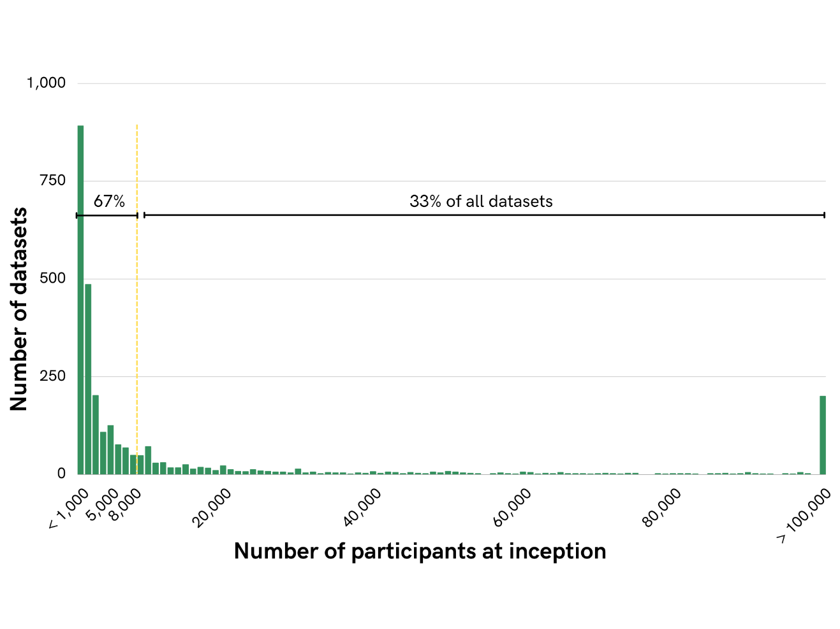
Figure 5. Sample size at inception for 3,068 identified longitudinal datasets
Note: Yellow line indicates selection criterion cut-off for the number of participants (N=8,000)

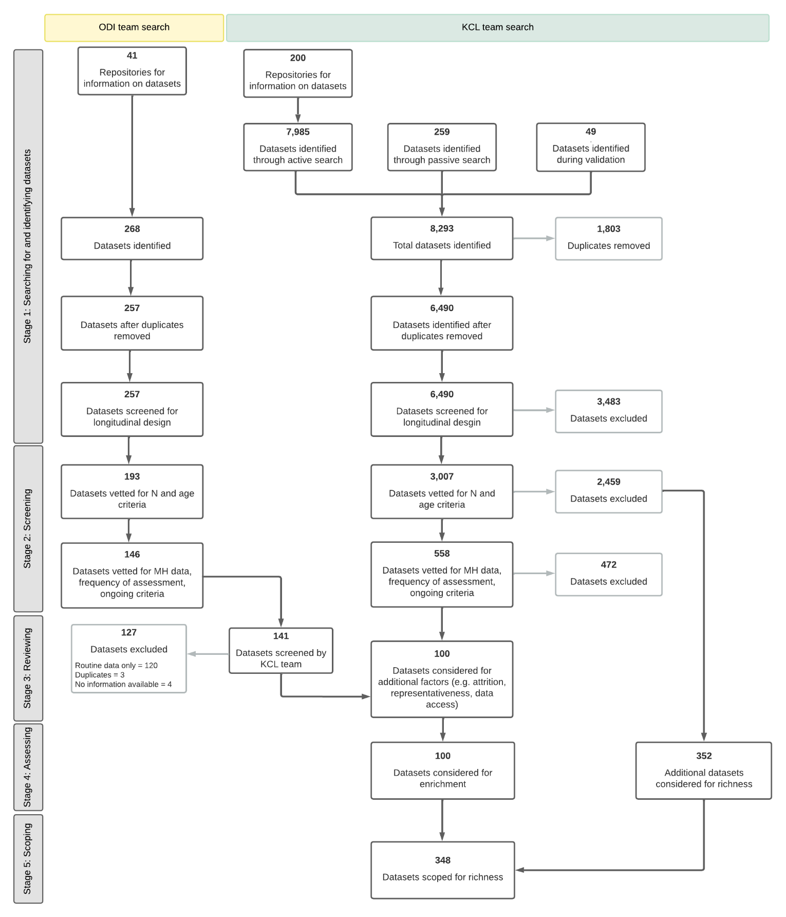
Figure 6. PRISMA flowchart reporting the number of datasets processed through the landscaping stages
Note: 'MH data' indicates 'mental health data', 'N' indicates number of participants in a dataset
We identified longitudinal datasets in 146 countries (Figure 7). Countries without longitudinal datasets were mostly LMICs. The absence of longitudinal datasets in those countries could be due to several factors. We noticed that some countries without longitudinal datasets do not cover a wide geographical area and are not densely populated. These countries often lack population research institutions and thus miss out on the opportunity to develop longitudinal datasets. Some countries do not have the stability required to conduct longitudinal research and may have been overlooked by large international institutions due to political instability. Moreover, some countries were not officially established until recently and thus do not have longitudinal data from years before that (World Bank, 2023).

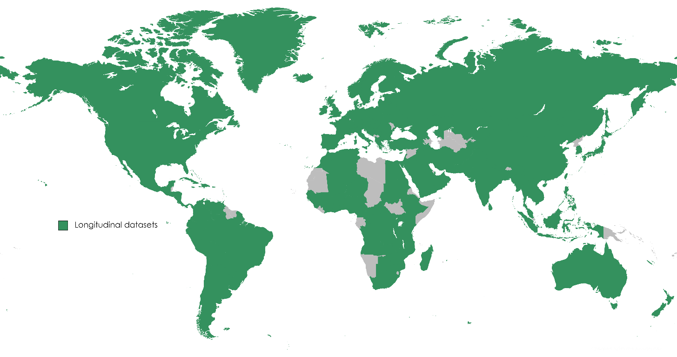

Figure 7. Countries with identified longitudinal datasets
Note: Countries without identified longitudinal datasets: Americas: Antigua and Barbuda, Belize, Bermuda, Dominica, Grenada, Guyana, St Kitts and Nevis, St Lucia, St Vincent and the Grenadines, Suriname; Africa, the Middle East & Asia: Azerbaijan, Bahrain, Bhutan, Brunei, Cape Verde, Chad, Comoros, Djibouti, Eritrea, Equatorial Guinea, Eswatini, Gabon, Liberia, Libya, Maldives, Mauritania, Namibia, North Korea, Sao Tome and Principe, Somalia, South Sudan, Syria, Turkmenistan, Uzbekistan, Western Sahara; Europe & the Pacific: Fiji, Kiribati, Kosovo, Liechtenstein, Marshall Islands, Micronesia, Moldova, Monaco, Montenegro, Nauru, Papua New Guinea, Samoa, San Marino, Solomon Islands, Tonga, Tuvalu, Vanuatu

Regional breakdown
While the purpose of our regional breakdown was to divide the workload, and was somewhat arbitrary, it provided some useful insights about the global landscape of longitudinal research.

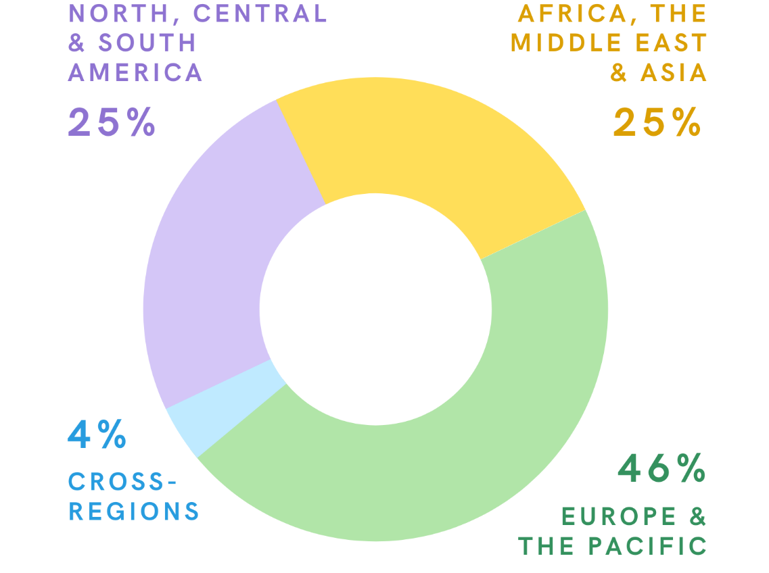
Figure 8: Proportion of longitudinal datasets identified from each geographical region

Africa, the Middle East & Asia: The longitudinal datasets we found while landscaping these regions varied in their focus and sample sizes. The 770 longitudinal datasets we identified can be divided into three broad foci: physical health, social and economic wellbeing and mental health.

The datasets that examine physical health form the largest group and concentrate on various communicable and non-communicable diseases including human immunodeficiency virus (HIV) and acquired immunodeficiency syndrome (AIDS), osteoporosis, stroke, tuberculosis and cancer. We also found several clinical trials for various drugs and medical interventions which were not considered as part of this project.

The second largest group are datasets focused on the life course. In general, these studies are household panels or cohorts and often investigate demographics, education, employment, wellbeing, nutrition, and relationships to understand the populations’ socio-economic situation.
Lastly, a small group of studies focus on mental health and related topics such as PTSD, self-harm and trauma.

Although most datasets in this region have been running for a shorter time than those from the two other regions, they are rich in information about the family and community-lives of individuals across a range of socio-economic levels, especially among those in the poorest communities. Many studies emphasise the community and relational aspects of social and economic wellbeing. This focus is evident through the various longitudinal designs, including household, family, three-generation, community, village and workplace panels. Overall, 81% of household panel design studies identified as part of the landscaping project are from this region.

Similar to the other regions, sample sizes range widely and 479 datasets (62%) had less than 8,000 participants at baseline. One dataset includes over a million participants. Despite the comparatively young populations in this region, 23% of datasets include participants over the age of 30 at baseline (N=177). We noted that a few studies (N=66) nded more than three years ago with no possibility of re-contacting participants, and therefore were not considered for enrichment.

Americas: We identified 773 longitudinal datasets in North, Central, and South America. Sample sizes are as large as 250 million participants for one dataset. The majority are prospective cohorts (90%), most of which focus on physical health conditions, or are birth or ageing cohorts following the natural development of people over time. The longitudinal datasets that focus on physical health conditions primarily examine cancer, cardiovascular disease, and HIV and AIDS. Almost all datasets focusing on physical health that are still active, recent or upcoming have collected biological samples for genetic research.

Of the longitudinal datasets identified in the Americas, 16% specifically focus on mental health or a mental health condition, with bipolar disorder and PTSD being the most common conditions. Irrespective of design or focus, most datasets are funded by government agencies (e.g., the National Institute of Health) and are led by researchers in academic institutions based in the United States of America (USA). In addition, the USA was found to be home to some of the world’s longest-running longitudinal datasets.

A small but notable proportion of the longitudinal datasets in the Americas are conducted within a coordinated series, based at the same institution and often led by the same study teams. Examples of these series include the Pelotas Birth Cohort Studies, the Nurses’ Health Studies and the affiliated Growing Up Today Study, and Framingham Heart Studies.

Over one fifth of the longitudinal datasets identified in the Americas (N=173, 22%) have more than 8,000 participants and, of those, 34% focused on mid to late adulthood with many specifically examining ageing. These ageing studies were not considered for enrichment as they are outside the age range criterion. Other datasets are either no longer collecting data or do not have enough information online to be reviewed further (N=87). This resulted in a total of 101 longitudinal datasets meeting Wellcome criteria in the Americas, of which, approximately half collected data on mental health (N=45).

Europe & the Pacific: This region is home to 46% of all longitudinal datasets we identified as part of the first landscaping stage (N=1,422). Of those, 1,211 (85%) are based in Europe, with 301 (25%) of the European datasets holding data from the UK. Small sample size (67%) and age of the participants (23%) were the main reasons for not considering datasets based in Europe and the Pacific for enrichment.

Most of the datasets identified in this region focused on early life. Two hundred and twenty-seven (16%) datasets from Europe and the Pacific collected data from birth or prenatally. This region is home to datasets with exceptionally long ongoing data collection. The primary focus of these datasets is physical health. However, Europe and the Pacific are home to datasets with extremely detailed mental health measures spanning several years.

Most datasets are managed by academic institutions or led by academic investigator(s). We also found several collaborative initiatives across academia and governments. This was most common among the numerous rich registries in Europe and datasets using routinely collected data. Over 40% of the registries and biobanks identified for this project are based in Europe.

Cross-regional datasets: We also identified 103 longitudinal datasets with participants who were recruited from countries that span the three different regions. We noticed that several of these cross-regional datasets were established recently to address the global impact of the COVID-19 pandemic. Furthermore, many of these collaborations involved institutions based in the UK and USA.

Several datasets identified via non-academic contacts across all regions, portals and desk research were large datasets such as disease registries or datasets based on routine healthcare data. While large registries technically met the selection criteria, we did not consider them for potential enrichment. Indeed, we anticipate limited possibility for enriching these datasets as the collection of additional types of data is highly unlikely. These datasets are collected routinely and the likelihood of asking healthcare professionals to collect additional data according to validated mental health measures would require a significant shift in policy. Furthermore, we expect limited scope for recontacting populations covered by these registries (e.g., public healthcare providers, insurance companies). We considered the value of registries with routinely collected data for mental health research in the section on richness of longitudinal datasets.

In numbers:
- 81% of household panel studies identified were from Africa, the Middle East or Asia
- 40% of registry datasets identified were from Europe or the Pacific
- 1 in 5 datasets from the Americas collect data from over 8,000 individuals

Pockets of value
Richness of longitudinal datasets worldwide
As part of our review of longitudinal datasets worldwide, we noted the richness of several datasets and the opportunities they offer for contributing to transformative mental health research. We categorised these exemplar datasets into 19 ‘pockets of value’ based on their value for different domains of mental health research (Figure 9).
Our review was informed and guided by three key elements: (a) Wellcome’s vision for transformative mental health research; (b) the input from stakeholders, and particularly LEEs, who either contacted us or participated in the ToC process; and (c) our experience of screening and reviewing thousands of longitudinal datasets from around the world.
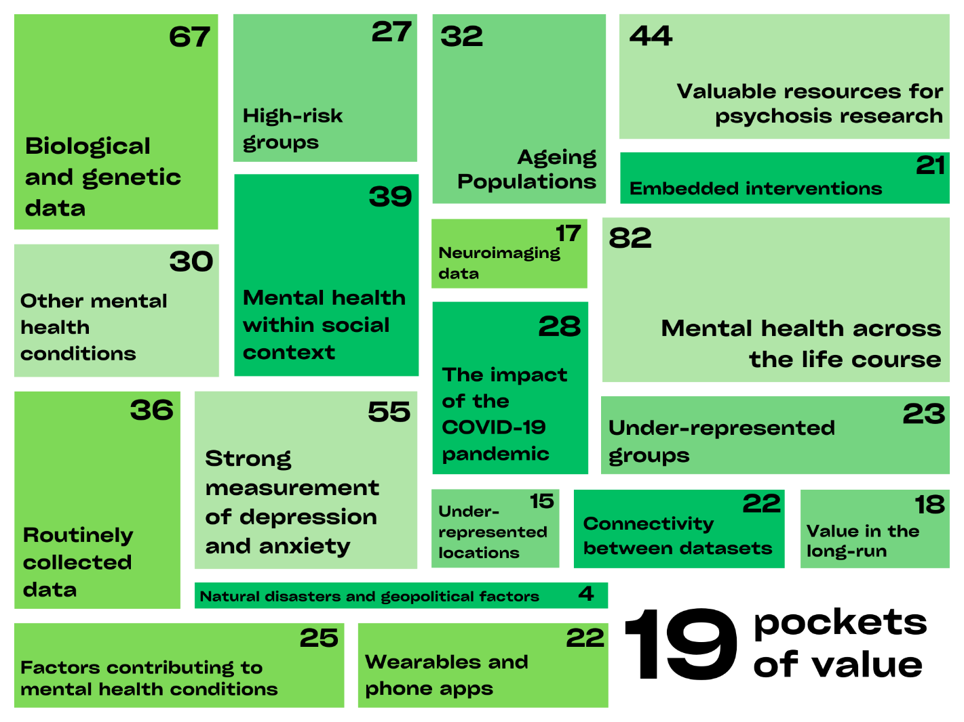
Figure 9. Number of datasets identified as examples for each pocket of value

A total of 348 longitudinal datasets were picked out to illustrate such richness. Richness was, to a certain extent, concentrated in a few datasets as close to half of them feature in more than one pocket of value (Figure 10).

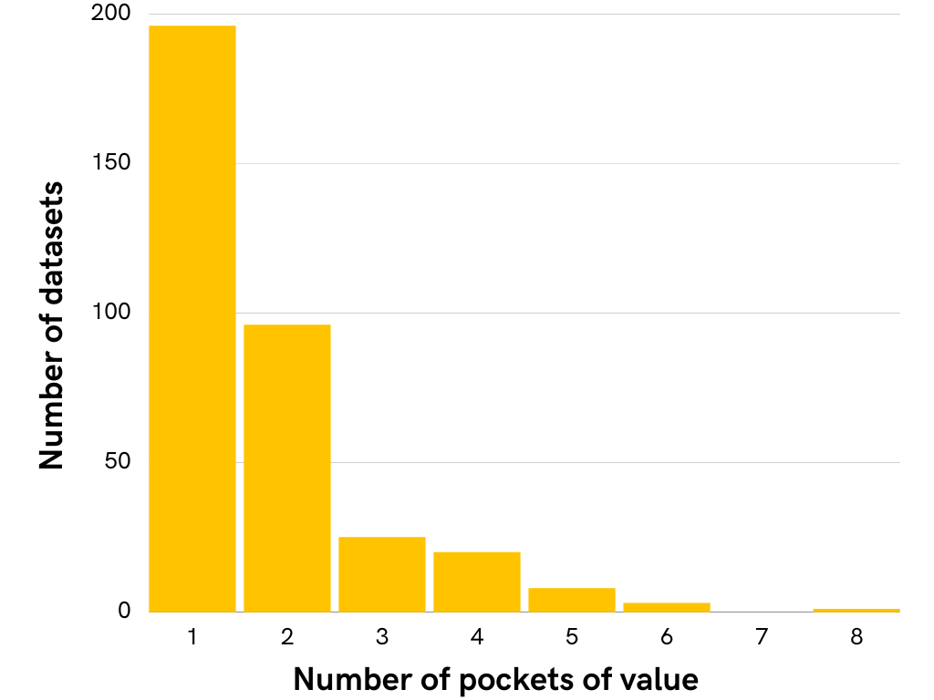
Figure 10. Frequency of datasets in one or more pockets of value (N=348)

Our analysis of the richness of existing longitudinal datasets is an appreciation of their exemplar value. We did not aim to provide complete lists of datasets: the number of datasets in each pocket of value is an estimate of the overall richness rather than being an exact value. We acknowledge that some valuable datasets are not highlighted in our analysis.

The contrast between pockets can inform current good practice and priorities for future research. For example, some pockets of value were illustrated with numerous exemplary datasets (e.g., strong measurement of anxiety and depression, valuable resources for psychosis research, and mental health across the life course) while others were few (e.g., natural disasters and geopolitical factors).

All three geographical regions contributed datasets to the pockets of value overall (Table 1): Americas (N=116, 15% of the total longitudinal datasets from this region), Africa, the Middle East & Asia (N=53, 6.9%), Europe & the Pacific (N=172, 12.1%) and cross-regions (N=8, 7.8%). We observed that some regions were especially rich with regard to specific pockets of value: Europe & the Pacific provided a high proportion of datasets with routinely collected data; the Americas are rich of datasets spanning across the lifespan; and datasets from Africa, the Middle East & Asia are often embedded in social context.

High-income countries provided more than their share of datasets to the pockets of value: 22.6% were from the USA, 15.5% from the UK, 7.7% from Australia, 6.9% from the Netherlands and 5.7% were collaborations across countries, including LMICs. Several datasets from the original pool of 3,068 did not include mental health measures and as such, they were not considered for any pockets of value.

Next, we describe below the 19 pockets of value and provide examples of datasets to illustrate such richness.

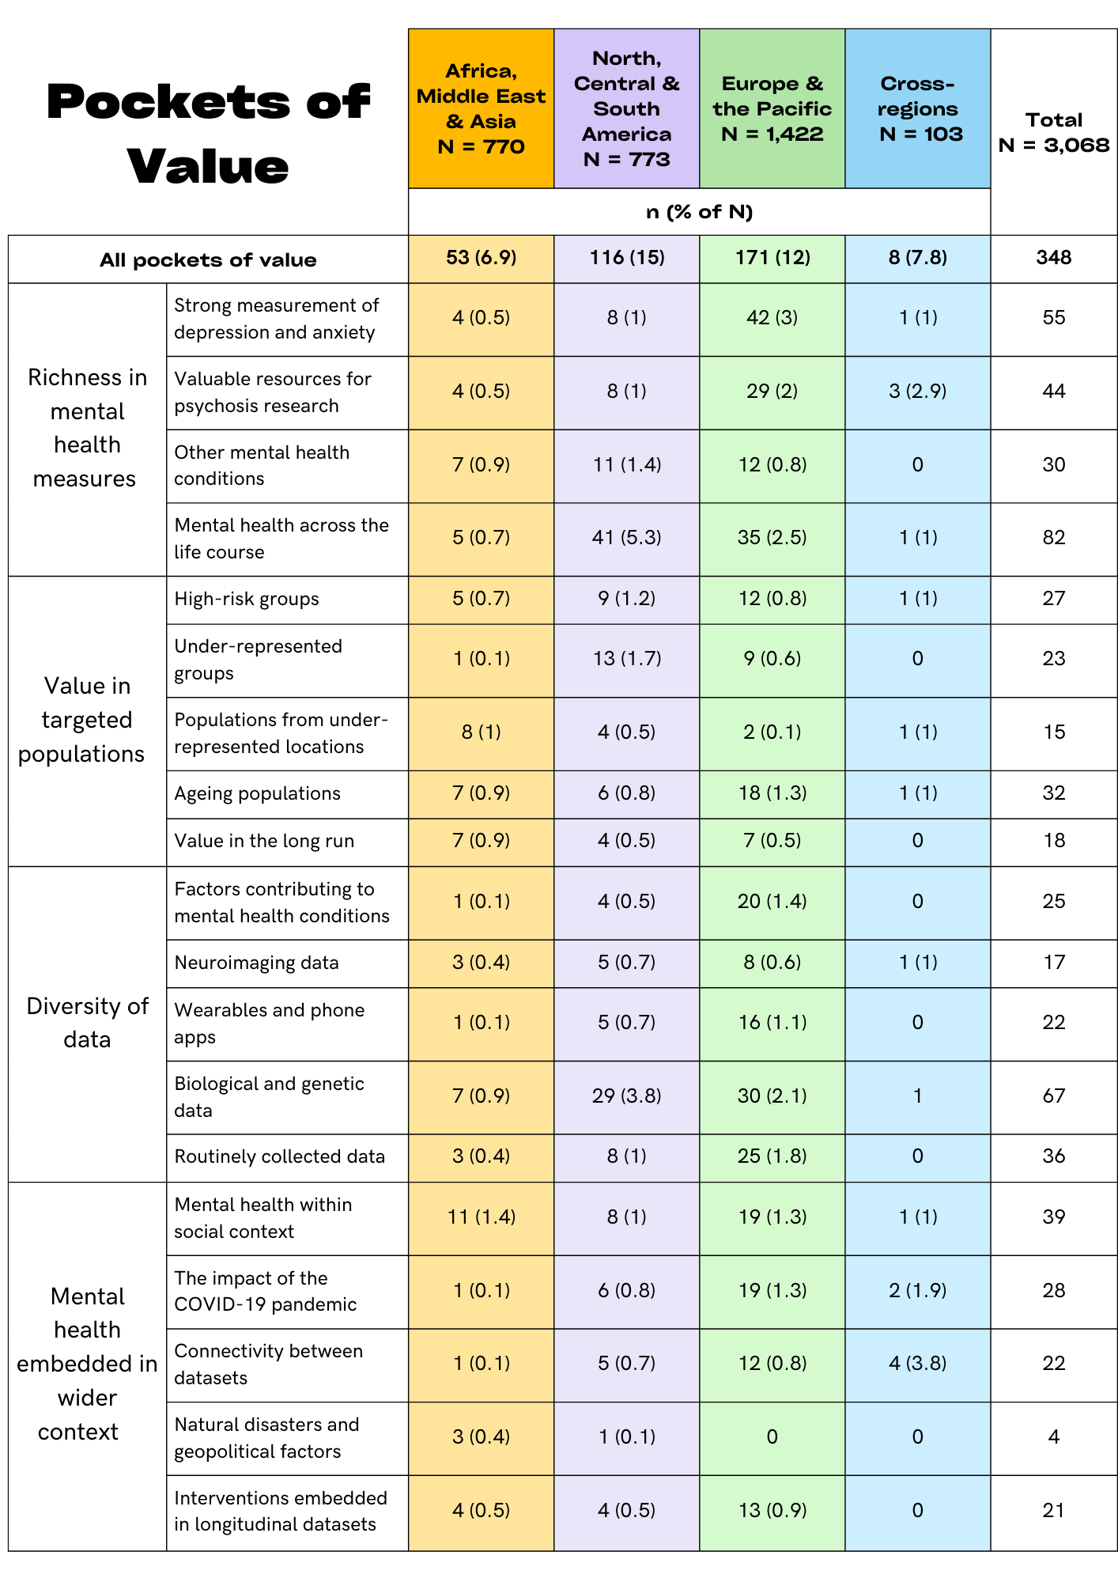
Table 1. Summary table of pockets of value across geographical regions
Note: N = number of studies

1. Richness in mental health measures

Strong measurement of depression and anxiety
Depression and anxiety are the most common mental health disorders worldwide (World Health Organisation, 2017a). To create a step change in early intervention, and to reduce high rates of depression and anxiety around the world, researchers require high-quality, repeated measures of these conditions during key developmental stages. Such data will provide the basis for in-depth analyses of the trajectories and resolution of each of these conditions.

In this pocket, we highlight 55 datasets with strong measurement of depression and anxiety. These datasets have utilised standard instruments to regularly track the development of these conditions across different life stages and important transitions. About a third of these datasets specifically focused on mental health (N=15), while the remaining datasets collected rich measures of depression and anxiety even though their focus was on other topics such as physical health. The majority of datasets in this pocket of value assessed both depression and anxiety (84%).

More than 30 different standard instruments were used to measure depression and anxiety across the datasets in this pocket only. The most common instruments were the Strengths and Difficulties Questionnaire (SDQ; Goodman, 1997), Patient Health Questionnaire (PHQ-9; Kroenke et al., 2001), the General Health Questionnaire (GHQ; Goldberg and Hillier, 1979), the Generalised Anxiety Disorder Assessment (GAD-7; Spitzer et al., 2006), and the Edinburgh Postnatal Depression Scale (EPDS; Cox et al., 1987) (Figure 11). Diversity in instruments can be a challenge for those aiming to compare and harmonise data across studies. However, it can be an asset for researchers looking for assessments adapted to the population they target, considering factors such as age, cultural differences and specific circumstances such as childbirth.

While it is important to adapt instruments as participants age, continuity of measurement needs to be considered for longitudinal analyses. The Australian Temperament Project provides a clear example of a dataset that has collected high-quality longitudinal, multi-informant data on depression and anxiety and, as a result, provides a rich resource for researching the onset, course and resolution of these conditions. This study has assessed depression and anxiety in over 2,000 participants since toddlerhood and up to age 28, every two years across 15 waves, and more recently has assessed participants’ offspring from birth to age six. The Australian Temperament Project adapted the assessment of the two conditions as participants grew older with introducing different standard age-appropriate instruments: the Child Behaviour Questionnaire in childhood (CBQ; Rothbart et al., 2001), the Short Mood and Feelings Questionnaire in adolescence (SMFQ; Angold et al., 1995), and the Depression Anxiety Stress Scale Short Form in adulthood (DASS-21; Henry and Crawford, 2005). When participants became parents, they were administered the DASS-21 alongside the EPDS to capture the potential impact of such an important life event on depression.

Most datasets rely on self-report measures of mental health. Those with measures collected from multiple informants and using different data collection modes can be extremely valuable, especially for triangulation, a practice that involves integrating results from different methodologies to strengthen findings’ reliability (Lawlor et al., 2016). The National Network of Depression Centers – Mood Outcomes Program is an example of an administrative dataset that used standard questionnaires to enhance routine clinical data. It is comprised of 26 care centres for patients with mood disorders such as depression and bipolar disorder. The participating sites have implemented, and now follow, a protocol to collect patient-reported assessments on depression and anxiety using standard measures (e.g., PHQ-9 and GAD-7) across the centres during their routine visits. These self-reported depression and anxiety data enrich the clinical data routinely collected in the centres, enabling research on clinical populations and supporting the standardisation of screening and monitoring of these conditions.

The TRacking Adolescents’ Individual Lives Survey (TRAILS), based in the Netherlands, similarly added value to their dataset by collecting information from multiple informants including participants, parents, siblings, peers, teachers and partners, and also via registry-based data provided by preventive child healthcare and mental healthcare providers. The study has been following the mental health and social development of 2,800 children and clinical cohort participants since ages 10 and 12. The Taiwan Birth Cohort Study (TBCS) is the first nationwide prospective representative study of children from birth in Taiwan. It is based on socioecological and life-course perspectives and has collected data on depression and anxiety for the past 17 years from the participants, mothers, fathers and teachers. This study is rich with a wide range of other types of data including family life, parenting and childcare practices, environmental measures and biological exposures.

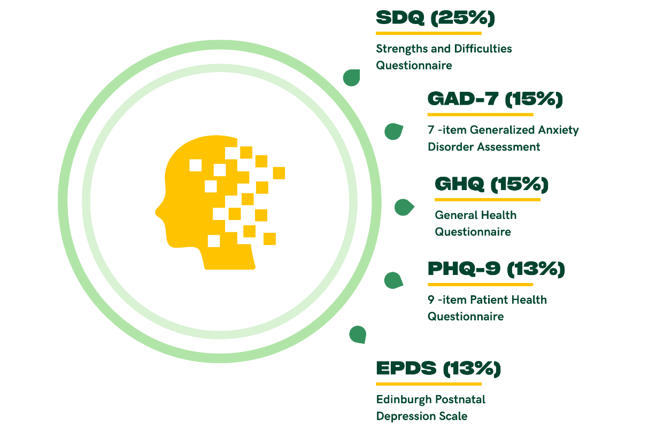
Figure 11. Common instruments used to capture depression and anxiety
Note: Percentage was calculated based on the datasets in this pocket only (N=55)

Valuable resources for psychosis research
As psychosis is a relatively rare condition (with an incidence rate of 26.6 per 100,000 person-years; Jongsma et al., 2019), large sample sizes are needed to provide researchers with the statistical power necessary for conducting analyses in general population samples. Yet, our review revealed a lack of granular data on psychosis in large samples. However, small scale studies with in-depth psychosis assessment in clinical or high-risk samples can enhance the examination of this condition.

In this pocket, we highlight 44 datasets with valuable data for psychosis research. Approximately half of these datasets were set up to examine specifically psychosis in high-risk populations or individuals with a psychosis diagnosis. We found rich datasets for psychosis research from all geographical regions, with Europe offering several data resources.

We noted that a number of initiatives pulled together resources focused on psychosis from different sites around the world to optimise the number of participants. The Accelerating Medicines Partnership Program - Schizophrenia (AMP-SCZ) is aiming to recruit from 42 sites in 14 high-income countries a cohort of 2,500 individuals experiencing symptoms that put them at high risk of developing schizophrenia for developing tools for the early detection of schizophrenia. The INTernational Research Programme on Psychoses In Diverse settings (INTREPID II) project has recruited 720 people with psychotic disorders, a close relative when possible and 720 matched controls in three sites in the Global South (i.e., India, Nigeria, and Trinidad) to investigate the incidence, presentation, outcome and impact of psychosis across these settings. These two projects collect a wide range of other types of data including clinical assessments and biological samples.

Large registries also provide rich administrative data on people diagnosed with psychosis. The Western Australian schizophrenia high-risk e-Cohort is a registry-based e-cohort of all births between 1980 and 2001 to mothers with a diagnosis of psychosis in Western Australia (20,209 children born to 9,750 mothers, with a comparison group of mothers with no diagnosis). PsyCymru is also a linked e-cohort of Welsh individuals living with psychosis. It consists of two studies, one focusing on approximately 1,000 people living with psychosis recruited from the community and another study based on 20,000 general practitioner (GP) linked administrative health records. PsyCymru is part of SAIL, a rich and trusted population databank in Wales. The large number of service users captured by these datasets offer sample sizes with sufficient power alongside real-world data on the service use experiences of people with psychosis. These registries can also offer the foundation for initiating new longitudinal cohorts of high-risk youth by recruiting offspring of parents with psychosis and allowing assessments in early life.

In numbers:
- 12% of datasets identified in this project included measures of psychosis
- 51% of datasets in this pocket focus on high-risk populations

Other mental health conditions

While Wellcome’s vision revolves around depression, anxiety and psychosis, other mental health conditions also have severe consequences for people’s lives (Treasure et al., 2020; Sylvia et al., 2017) and require further research. The examination of other mental health conditions is also worthwhile to better understand psychiatric comorbidity, the co-occurrence of more than one condition. Psychiatric comorbidity has been shown to be the norm rather than the exception (Caspi et al., 2020).

In this pocket, we highlight 30 datasets with in-depth assessment of mental health conditions other than depression, anxiety and psychosis. These datasets tend to examine a specific mental health condition or a particular situation that increases risk for mental illnesses (e.g., trauma). One third of these datasets (37%) focused on mental health, while the majority primarily targeted physical health, socioeconomic or general life course outcomes but also included detailed assessments of mental health. Together, they have accumulated robust and granular measures of various mental health conditions including PTSD, conduct disorder, bipolar disorder, panic disorder, binge-eating disorder, bulimia nervosa, and alcohol use disorder, as well as other issues related to poor mental health such as self-harm and suicidality.

Datasets with rich PTSD data typically focus on high-risk populations because of trauma exposure, most often among military personnel and veterans in countries with large armed forces. Military studies such as the Millennium Cohort Study in the USA, the Australian Gulf War Veterans’ Health Study Cohort and the Health and Wellbeing of UK Armed Forces Personnel cohort are large cohorts that have repeatedly collected detailed data on PTSD, as well as measures of depression and anxiety amongst armed forces personnel. There are also a number of studies examining PTSD in other populations including victims/survivors of abuse (e.g., Child and Protection National Minimum Data Set) and migrants and refugees (e.g., Biological pathways of risk and resilience in Syrian refugee children (BIOPATH)). These studies maximise the likelihood of observing people affected by a range of mental health conditions by virtue of their experience with a determined risk factor.

Many datasets with rich data on mental health conditions other than depression and anxiety focus on individuals diagnosed with a specific condition. For example, bipolar disorder has been examined in studies such as the Prechter Longitudinal Study of Bipolar Disorder which includes 834 middle-aged participants with a diagnosis of bipolar disorder, major depressive disorder, other mood or non-mood/non-affective disorders, and 277 healthy controls. This study conducted detailed assessments of mood symptoms during frequent follow-ups that covered a range of mental health symptoms using standard questionnaires such as the Altman Self-Rating Mania Scale (ASRM; Altman et al., 1997), PHQ-9 and GAD-7, providing uniquely rich data for studying bipolar disorder.

Conversely, some datasets in this pocket allow for the examination of a range of mental health conditions in the general population. For example, trajectories of self-harm and suicidality have been examined by the Positive Adolescent Training through Holistic Social (PATHS) Programs – Longitudinal Study which follows 2,023 grade-12 students in Hong Kong. The inclusion of measures of self-harm and suicide facilitates research on the link between these experiences and other topics of interest, such as development, economic disadvantage, and family functioning in a representative sample.

Mental health across the life course
Long-standing longitudinal studies are powerful research resources as they allow the examination of within-individual change through life, sometimes but rarely, from cradle to grave. As people move in and out of mental wellness, it is especially valuable when studies are not limited to specific age periods, but instead, aim to investigate stability and change across key developmental periods and cover multiple important life transitions such as school entry, moving into the job market, parenthood and retirement. These long-term longitudinal data allow for the reconsideration of basic features of mental health conditions, such as onset and peak prevalence as society changes and evolves.

In this pocket, we highlight 82 datasets exemplary for their longevity and repeated assessment of mental health conditions. These datasets have followed the health and development of their participants since early in life, providing measures of contributory factors prior to the onset of mental health conditions. While only a minority of these studies initially focused on mental health (12%), through the years they have collected a wealth of data on various mental health conditions. Given the long-term financial investment needed to maintain these valuable data resources, it is not surprising that all these datasets are based in high-income countries.

The National Child Development Study (NCDS) and the 1970 British Cohort Study (BCS70) are two examples of longstanding longitudinal studies with repeated mental health assessment in the UK. Each of these studies have followed a nationally representative sample of over 17,000 individuals from birth, with the NCDS cohort entering their mid-60s and BCS70 participants in their early-50s in 2023. These studies provide rich sources of data for mental health research as they have collected repeated measures of psychological distress, for example, using the Malaise Inventory (Rodgers et al., 1999), as well as measures of loneliness, life events, victimisation, employment, parenting and social care across over five decades.

We noticed that a number of the studies in this pocket are location-based and have extensive engagement with participants. For example, the Dunedin Multidisciplinary Health and Development Study is a birth cohort of 1,037 New Zealanders born in Dunedin 1972-73.
These individuals have been followed every two years until the age of 15 and approximately every three to six years ever since, with 949 participants continuing to take part as they enter their fifth decade. This study has collected abundant data on mental health through the years alongside a panoply of environmental factors and health indicators and maintained high retention of participants, possibly because of its engagement with participants and the local community.

Some of the datasets have also captured information on more than one generation by collecting data on participants’ offspring when they became parents. These data are especially rich as they allow for the investigation into the processes that underlie transgenerational transmission of elevated risk for mental health conditions, whether genetic or environmental. For example, the Netherlands Study of Depression and Anxiety (NESDA) has followed around 3,350 participants aged between 18 and 65 with a remitted or recurrent diagnosis of depression or anxiety, their siblings and matched controls for 13 years, and recently recruited a subsample of their offspring from ages 10 to 25. Similarly, the Growing Up Today Study (GUTS) has followed more than 27,000 participants from age 9 and 17 between 1996 and 2004 in the USA and is now collecting data on their offspring.

2. Value in targeted populations

High-risk groups
Mental health conditions are not evenly distributed across the population, with some groups at increased risk for experiencing severe and recurrent mental ill health. Individuals may be at risk because of factors including (but not limited to) exposure to stressful or traumatic events (McKay et al., 2021; Hoppen et al., 2021), poor neighbourhood conditions (Visser et al., 2021), occupational hazards (Harvey et al., 2017; McFarlane & Bryant, 2007) or their genetic background (Lawrence et al., 2019). While high-risk groups are included in longitudinal general population samples, there is value in concentrating on specific groups to investigate how these risk factors operate.

In this pocket, we highlight 27 datasets that focus specifically on groups with liability for developing mental ill health. Most of these datasets focused on mental health (67%) and collected data on a range of conditions including depression, anxiety, psychosis, bipolar disorder, PTSD, post-natal depression, and substance use disorder.

Nearly half of these datasets started collecting data in childhood, a period when critical risk factors such as abuse, neglect, experience of out of home care or the child protection system, substance use in the household and family violence are more likely to occur. Other factors conferring a risk for mental health conditions covered by these studies included alcohol or substance use, high-risk occupations (e.g., military personnel), experience of violent conflicts (e.g., refugees from war-torn countries) and genetic liability (e.g., individuals with relatives diagnosed with a psychiatric disorder).

Some datasets in this pocket recruited sub-samples of participants at increased risk of mental illness based on family history. The Brazilian High Risk Cohort Study recruited a sample of 2,511 Brazilian children and included a community representative sub-sample and a high-risk sub-sample based on children’s family history. Similarly, the Pakistan-based Bachpan Study screened pregnant women for depression and recruited 584 women with high depression scores, as well as 570 women without depression. Since then, mother-baby dyads have been assessed annually for seven years, with a focus on childhood mechanisms through which maternal depression and its treatment shape children's developmental trajectories.

A number of these datasets examined populations in occupations with elevated risk for mental health conditions. For example, NHS-Check monitors the health and wellbeing of 23,000 healthcare workers in the UK. It was established during the COVID-19 pandemic, an especially straining period for this occupational group. Participants’ mental health was assessed during the pandemic using instruments including the GHQ-12, Clinical Interview Schedule-Revised (CIS-R; Subramaniam et al., 2006), PTSD Checklist – 6 (PCL-6; Lang and Stein, 2005) and the Clinician Administered PTSD Scale for DSM-5 (CAPS-5; Weathers et al., 2018). Assessment of depression, anxiety and PTSD has continued in follow-up surveys. These data allow for research on the impact of occupational risk factors on frontline healthcare workers’ mental health.

Under-represented groups
Minoritised and marginalised groups are often under-represented in or absent from epidemiological studies (Smart & Harrison, 2017). This under-representation is the result of a wide range of factors including histories of racism in research and resulting mistrust in research institutions, language barriers (such as for ethnic minorities and migrants), potential risks involved for participants (such as for LGBTQIA+ individuals), lack of inclusive research practices (such as for neurodivergent individuals; Fletcher-Watson et al., 2021), limited outreach of traditional recruitment methods (e.g., groups with limited technological literacy, unhoused people) or inadequate concerns about attrition of individuals at high risk of mental health problems (e.g., children with disruptive behaviours; Wolke et al., 2009). As a result of this under-representation in epidemiological research, it remains unclear whether findings from some large longitudinal datasets are generalisable to these groups.

In this pocket, we highlight 23 datasets targeting groups typically underrepresented in epidemiological research. The groups prioritised by these studies include racially and ethnically minoritised individuals, LGBTQIA+ people, migrants, neurodivergent individuals, prisoners and unhoused people. These datasets cover multiple mental health conditions including depression, anxiety, psychosis and PTSD. Very few of these datasets were based in Africa, the Middle East or Asia.

We observed that several datasets from the USA, a country with a racially diverse population, prioritised the recruitment of racially diverse samples or samples of minoritised populations. For example, Mexican-origin youth are the largest and fastest growing ethnic minority group in the USA, and they disproportionately experience poverty, unemployment, and low educational attainment. The California Families Project (CFP) has recruited a cohort of 674 Mexican-origin families who have been followed up annually across 13 waves of data collection since 2006 when the children were 10 years old. Aside from data on familial and cultural factors, detailed data have been collected on depression and anxiety using the Mini-Mood and Anxiety Symptom Questionnaire (MASQ; Watson et al., 1995a, 1995b) and the Major Depressive Disorder and Generalised Anxiety Disorder subscales of the National Institute of Mental Health (NIMH) Diagnostic Interview Schedule for Children-IV (DISC-IV; Shaffer et al., 2000).

A very small number of datasets focused on samples of young people experiencing homelessness. The Residential Trajectories of Street Youth-the Montréal Cohort Study was established in 2006 and conducted interviews with 365 participants every three months. The study used rigorous follow-ups to capture the transient nature of street youth life. Assessment included depression, anxiety, bipolar disorders, anorexia/bulimia, schizophrenia, and alcohol/drug-related disorders with the World Mental Health Composite International Diagnostic Interview (CIDI; Robins et al., 1988). Unfortunately, the study stopped after two years, highlighting the challenges of conducting longitudinal research with vulnerable groups in the population.

Populations from under-represented locations
Our worldwide review of longitudinal datasets revealed gaps in data resources from a number of small countries, particularly among LMICs. Indeed, longitudinal research requires sizeable populations and substantial financial investment to support research activities over several years, and small, low-income countries may have pressing economic or social issues that are prioritised ahead of mental health research. However, as a result of this under-representation, worldwide figures may not accurately capture mental health in the context of several LMICs, many of which face unstable political situations, experience precarious economic conditions, and have unique cultural perspectives that may shape the experience, prevalence and course of mental health conditions.

In this pocket, we highlight 15 datasets from locations rarely represented in longitudinal research. Except for Iceland and Hungary, they are all based in LMICs in Africa and Asia (Figure 12). The Malawi Longitudinal Study of Families and Health (MLSFH) is one of the few long-standing publicly available African longitudinal cohort studies. It has followed over 6,000 individuals since 1998 during which depression and anxiety have been assessed with the Short Form Health Survey 12 question (SF-12; Ware et al., 1996), PHQ-9 and GAD-7. To adapt these standard instruments to the study population, the study team did not implement clinical cut off scores, but instead treated scores linearly/continuously in analyses.

Some of the datasets in this group (40%) focused on physical health, which is a major concern across the world, but especially in LMICs. The Mauritius Child Health Project is a birth cohort of 1,795 children that focuses on early child health and development and the identification of early risk factors for mental ill health. Spanning across 37 years, the study has enrolled three generations of families for mental health assessment including depression, anxiety, psychosis and PTSD using standard measures. Mauritius is an island with a diverse cultural background. People with mental health conditions are stigmatised in Mauritian society today, creating important barriers for access to treatment (Ramphul, 2018).

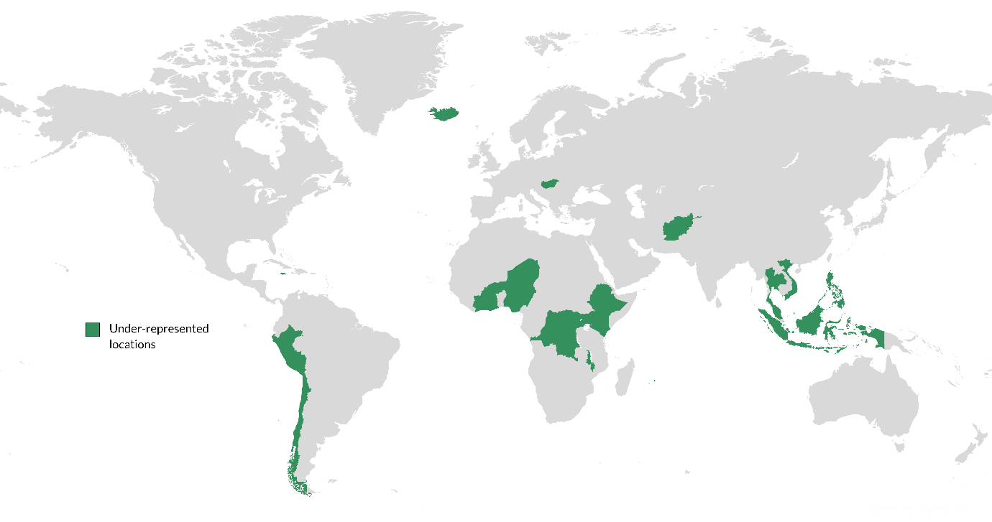
Figure 12. Under-represented countries in longitudinal research
Note: Under-represented countries in dark green: Afghanistan, Bangladesh, Burkina Faso, Chile, Democratic Republic of Congo, Ethiopia, Ghana, Hungary, Iceland, India, Indonesia, Ivory Coast, Jamaica, Kenya, Malawi, Malaysia, Mauritius, Niger, Nigeria, Pakistan, Peru, Philippines, Tanzania, Thailand, Timor-Leste, Uganda

Ageing populations
People worldwide live longer; the World Health Organisation reported that all countries in the world are experiencing growth in both the size and the proportion of older persons in the population (World Health Organisation, 2022). Research covering the later years of life most frequently aims to understand cognitive decline and conditions specific to this age group such as dementia. While mental health conditions remain prevalent due to stressors such as bereavement, illnesses and loneliness (World Health Organisation, 2017b), mental health has not been frequently monitored during this age period.

In this pocket, we highlight 32 datasets with valuable data on the mental health of ageing populations. Participants’ age at the inception of these datasets ranged from 45 to 80 with samples covering a range of socioeconomic groups including some studies focusing specifically on society’s poorest. Only 9% of these datasets focused specifically on mental health and several were set up to study the transition between work and retirement. While we identified datasets from countries with the highest life expectancy rates such as Japan and Italy, they primarily focused on physical health and did not assess mental health conditions.

Studies such as the English Longitudinal Study of Ageing (ELSA), the Irish Longitudinal Study on Ageing (TILDA), the Northern Ireland Longitudinal Study of Ageing (NICOLA), and the Panel on Health and Ageing of Singaporean Elderly (PHASE) were designed to study factors that influence the ageing process using representative samples of national populations aged 50 years and older. Data were collected on various topics, including physical health, cognition, wellbeing, loneliness, socioeconomic and genetic factors, and assessed mental health conditions such as depression, anxiety and PTSD.

In numbers:
- 22% of the world's population will be over aged over 60 by 2050
- 2 billion people will be aged over 60 by 2050

Value in the long run
During our review of longitudinal datasets from across the world, we unearthed datasets that offer great promise for future mental health research. These new and emerging initiatives are either funded projects that are still in the piloting stages, databases with ongoing recruitment, or samples of pregnant women. These datasets will not deliver findings for a few years and some will require further funding to proceed. However, they offer huge potential for mental health research if they include high-quality mental health assessment.

In this pocket, we highlight 18 datasets that will offer rich possibilities for mental research in the future. Some of these can provide new opportunities to focus on the development of mental health conditions from early life. This is in contrast to several established datasets where mental health became of interest several years after inception.

Some of these datasets are either upcoming or recently established cohorts of infants. For example, Children of the 2020s is a new cohort that will follow 8,500 children and their families. The oldest children in the study are now three years old and will be closely followed, along with their families, using smartphone apps to examine how recent events affect their physical, mental and emotional development.

We also noticed several recently established studies that have collected detailed profiles on a sample of mothers, which have potential to further the investigation of the transgenerational transmission of risk for mental illness if their offspring continue to be followed closely. Many of these new datasets have already collected biological samples, contrasting with many longer-standing datasets that collected specimens several years after inception. This may reflect a focus on physical health or the rise in genomic research for mental health discoveries and precision medicine (Gameiro et al., 2018). An example of this is the Alliance for Maternal and Newborn Health Improvement (AMANHI) biobanking study. AMANHI is a mother-and-baby cohort based in Bangladesh, Pakistan and Tanzania that has collected epidemiological, biological, phenotypic and clinical data from 10,001 women who have now given birth to 9,938 babies. Given the wealth of information already collected on mothers, there is great potential with enrolling babies to expand this study into a new intergenerational dataset across three LMICs.

Furthermore, two recent initiatives aim to set up centralised database for researchers wanting to enrol patients (e.g., Our Future Health in the UK) or volunteers (e.g., All of Us in the USA). Both have ongoing recruitment via administrative records, and expect to generate very large samples. As such these databases have the potential to facilitate and augment physical and mental health research by making rich population-wide routinely collected data available to researchers.

3. Diversity of data

Factors contributing to mental health conditions
Discovering new and improved ways to predict, identify and intervene as early as possible to reduce depression, anxiety and psychosis requires a greater understanding of the factors involved in the onset and persistence of these conditions. Causal questions can be answered in longitudinal epidemiological datasets with appropriate methods (DeStavola et al., 2022; Pingault et al., 2018). Longitudinal studies with granular assessment of mental health conditions alongside these factors provide the tools for building a better understanding of mental ill health and for robust tests of the factors that may contribute to its development.

In this pocket, we highlight 25 datasets that have detailed measures of a range of risk factors and collected repeated measures of mental health throughout participants’ lives, including early measurement prior to onset of the conditions. These datasets have the necessary data for testing the temporality between risk factors and mental health conditions. Some datasets have collected information about several confounders, including genetic data.

For example, the Great Smoky Mountains Study in the USA and the Avon Longitudinal Study of Parents & Children (ALSPAC) in the UK are two seminal prospective longitudinal studies that collected data on a range of early risk factors from early on in life, along with repeated assessments of various mental health conditions. Together, they capture risk factors including childhood maltreatment, family functioning, poverty, unsafe neighbourhoods, experiences of abuse or discrimination, stressful or traumatic life events and social isolation. ALSPAC’s dataset is supplemented with administrative data, specifically through linked health, education, environmental, and social media records. As participants of these two studies progress through life, new risk factors are being considered. DNA samples have also been collected for investigating genetic influences on the development of mental health conditions.

Twin studies offer a valuable study design for untangling genetic and environmental influences on mental health conditions and examining important mechanisms such as gene–environment correlations and interactions (Hagenbeek et al., 2023). An example is the Environmental Risk (E-Risk) Longitudinal Twin Study, which has followed a cohort of 2,232 twin children born in England and Wales who are part of a large registry of twins, the Twins Early Development Study (TEDS). A wealth of data that has been collected since participants were 5 years old, including measures of family environment, violence victimisation, neighbourhood conditions, social isolation and loneliness, sleep and pollution, and biomarkers including DNA samples. These data, in combination with the twin design, allow for robust tests of the contribution of early risk factors to the development of depression, anxiety and psychosis while considering genetic confound.

Neuroimaging data
Neuroimaging data are important for improving understanding of how brain, body and environment interact in the trajectory and resolution of depression, anxiety and psychosis, a key component of Wellcome’s vision. The challenges associated with collecting neuroimaging data as part of longitudinal research are not insignificant, as collecting this type of data is expensive, often takes place in a designated clinical setting, and requires team members with specialised skills for collecting, processing and analysing the data. Consequently, a small number of longitudinal datasets have collected neuroimaging data for longitudinal mental health research.

In this pocket, we highlight 17 datasets that provide windows to the brain through neuroimaging techniques such as magnetic resonance imaging (MRI), functional magnetic resonance imaging (fMRI) and structural fMRI. The focus of these studies was mostly on depression (38.9%) but other mental health conditions included anxiety, psychosis, PTSD and bipolar disorder (Figure 13). None of these datasets were based in LMICs, likely because of the costs and technical resources involved in collecting such valuable data.
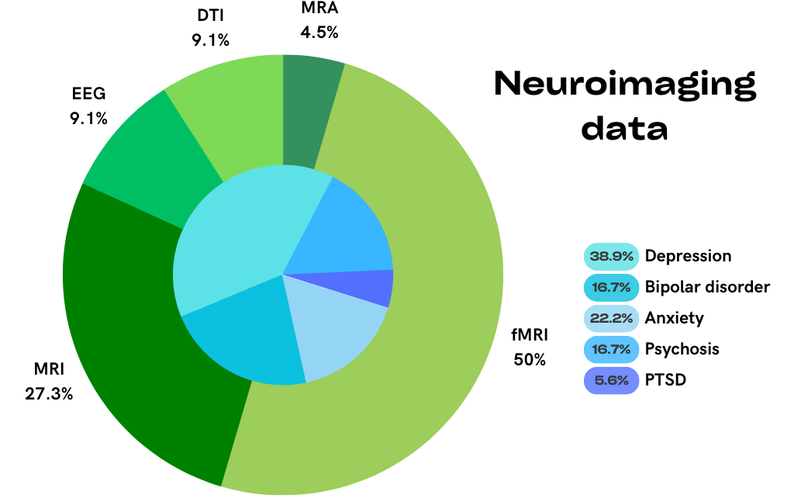
Figure 13. Neuroimaging techniques and mental health conditions in datasets with neuroimaging data
Note: Neuroimaging techniques: fMRI – Functional Magnetic Resonance Imaging, MRI – Magnetic Resonance Imaging, EEG – Electroencephalogram, DTI – Diffusion Tensor Imaging, MRA – Magnetic Resonance Angiography

Because of the resource intensity of neuroimaging, most studies collect data from a selected portion of their sample. For example, FinnBrain is a birth cohort of 3,837 infants born between 2011 and 2015. In addition to collecting data on parents’ anxiety and depression and infants’ temperament and emotional regulation, EEG and imaging data have been collected from subsamples of close to 200 children via MRI scans at three timepoints, starting when the children were as young as 1 month old. The Healthy Brain Network is one of the few datasets that aims to study child and adolescent brain development in the whole sample. It has recruited 10,000 participants and plans to use multimodal brain imaging (resting and naturalistic viewing fMRI, diffusion MRI, morphometric MRI), and electroencephalography (EEG), in hand with clinician-administered mental health assessments such as the Kiddie Schedule for Affective Disorders and Schizophrenia (K-SADS-5; Kaufman and Schweder, 2004; Kaufman et al., 2016) and questionnaires, to identify biological markers of mental health conditions for early intervention.

Wearables and phone apps
New technologies provide exciting opportunities for novel data collection methods that can add value to data collected using traditional questionnaire and interview methods. Wearables provide objective assessments of biological variables related to mental health, while mobile phone apps can facilitate momentary time sampling that allows for assessments of behaviours and feelings as they occur. These methods remain expensive, however, and are not free of challenges especially regarding data processing and analysis.

In this pocket, we highlight 22 datasets that have used wearables and phone apps to collect data. These datasets have mostly used fitness watches that capture indicators of sleep, physical activity, fitness, body temperature and heart rate. The majority of these datasets (56%) have a mental health focus, and two have also collected neuroimaging data.

A dataset that harnesses new technology is the ABCD Study. ABCD is the largest American cohort assessing brain development longitudinally with annual data collection since it was established in 2018. Fitbit watches are used to collect measures of resting heart rate, physical activity and sleep at every wave of data collection, and detailed neuroimaging data are collected every two years. Data from Fitbits amplify the investigation of the link between mental and physical health, using state-of-the-art measures, especially as they are paired with data from biological samples, parent and self-reported measures of mental health collected using standard instruments and linked education and residential history records.

A number of the datasets in this pocket use mobile phone applications for data collection. For example, the Mom2B Study utilises a mobile app for both active and passive data collection with their sample of 5,000 women living in Sweden who are either pregnant or up to 3 months post-partum. Active data collection consists of the participants responding to questionnaires related to mental and physical health, lifestyle, and social circumstances such as the EPDS, The World Health Organisation-Five Well-Being Index (WHO-5; Topp et al., 2015; World Health Organisation, 1998) and DSM subscales. Supplemental data are collected passively via smartphone sensors and activity logs on participants’ smartphone usage, geographical movement patterns, social media activity and behavioural metadata (i.e., time taken to respond to questions). These behavioural metadata can add further value by providing clinically relevant information on attention, processing speed, working memory capacity and even deterioration of mental health symptoms. Data linkage provides additional information about clinical diagnoses, care received, and prescribed medication.

Biological and genetic data
The study of mental health conditions transcends the mind and extends to biological and genetic factors. The contribution of genetic factors on depression (Kendall et al., 2021), anxiety (Ask et al., 2021) and psychosis (Legge et al., 2021) is indisputable. Scientific advances allow a precise and fine-grained exploration of these influences at relatively low cost today (but still requires large sample sizes). Furthermore, biological measures provide valuable information to study physical symptoms (e.g., weight loss or sleep problems) or the reciprocal influences between mental and physical health throughout the life course.

In this pocket, we highlight 67 datasets with biological and/or genetic data. Most of these datasets are also included in other pockets, such as ‘strong measures of depression and anxiety’ and ‘mental health across the life course’, reflecting the strength of the studies collecting these types of data. We noticed that studies of twins are ones to often collect DNA for molecular genetic/genomic analyses, in addition to traditional behavioural genetics. All datasets in this pocket collected genetic data, and approximately half (N = 36) also collected a range of other biological data.

Important sources for biological data are biobanks that can be found in several countries across the world. Biobanks enable the storage of various biomarkers that are relevant to different diseases, or sometimes specific conditions, and usually recruit very large samples of volunteers such as in the Estonian Biobank, the Qatar Biobank and the UK Biobank with sample sizes ranging from 60,000 to 500,000 participants. Large initiatives have also been initiated by corporations, such as 23andMe, and enable longitudinal research on mental health, as seen in the Affective disorders, Environment, and Cognitive Trait (AFFECT) study. Biobanks often rely on groups of volunteers which may introduce bias when estimating the magnitude of effects (Schoeler et al., 2023). Alternatively, some biobanks specifically cover clinical populations such as the Mayo Clinic Biobank across multiple sites across the USA, while others are linked to national healthcare systems, such as the collection of Finnish biobanks (all part of Fingenious), capturing broad populations.

Some longitudinal studies have amassed several biomarkers through the years. The Generation R Study has been following 9,749 children living in the Netherlands and includes biological samples collected at three points during pregnancy, at birth and at five time points after birth. Samples were collected from the children, mothers and their partners. Biological samples included blood, urine, saliva, and nasal swabs, for storage, DNA extraction or RNA isolation. While longitudinal datasets are usually smaller compared to biobanks, their repeated measurement of biological material and mental health measures enables the tracking of effects over time and since early on in life.

Genetic research frequently involves the collaboration of large consortia such as the Psychiatric Genomics Consortium for maximising statistical power. Genetic research is largely focused on populations of European descent (Bentley et al., 2017). This is reflected here with only 10% of the datasets in this pocket based in Africa, the Middle East & Asia. However, changes are underway with initiatives like the Psychiatric Genomic Consortium – Africa Working Group that facilitates the recruitment of individuals from a historically under-represented ethnic group. We also observed a number of datasets collecting genetic data in non-Caucasian populations, and particularly in Asia, such as the Taiwan Biobank, the Born in Guangzhou Cohort Study in China and the Growing Up in Singapore Towards healthy Outcomes (GUSTO) Birth Cohort Study.

Routinely collected data
A wealth of data is being routinely collected as individuals engage with services such as healthcare, education and social welfare systems. Registries of routinely collected data, often managed by governments or large companies, can provide basic information on vast populations or define targeted groups for longitudinal research. Linkage of cohort and routine data can provide an additional source of information for longitudinal research without imposing additional burden on participants and while enhancing the value for mental health research (Milne et al., 2022).

In this pocket, we highlight 36 datasets with routinely collected data. High-income countries generated most of these datasets which may reflect the need for developed and integrated healthcare infrastructure to capture large volumes of routine health data. This is particularly evident in the Scandinavian countries, where highly integrated government-maintained health and social welfare systems have facilitated the creation of nationwide public registries of individual-level data collected for administrative purposes (Smith Jervelund and De Montgomery, 2020). Personal identification numbers that have been assigned to all residents in the Nordic countries since the mid-1960s make it possible to link individual data from different registries, allowing for life-long follow up not possible in most other countries.

The Danish LIFE course (DANLIFE) cohort is an example of the potential for integrating routine data. DANLIFE is a registry-based cohort investigating the link between childhood adversity and life-long health and well-being using data from all children born in Denmark since 1980. Another example from Scandinavia is the Norwegian Mother, Father and Child Cohort Study (MoBa), a national pregnancy cohort that aims to detect the causes of serious disease with 112,908 families with pregnancies between 1998 and 2008. MoBa is a very rich resource for researchers offering granular assessments of mental health using standard instruments. Mental health data were regularly collected from children, mothers and fathers. The cohort is linked with multiple national health registries, including the Medical Birth Registry, National Patient Registry, Cause of Death Registry, Prescription Database, Vaccination Registry and Cancer Registry. The participants are now between the ages of 14 and 24.

In the UK, the Clinical Record Interactive Search System (CRIS) facilitates research by aggregating psychiatric clinical records from all patients accessing care in the South London and Maudsley National Health Service (NHS) Foundation Trust. Researchers can link information about treatment and care in the Trust to local GP records. CRIS enables researchers to access these data while protecting patients’ personal details.

In numbers, the primary sources of data in datasets incorporating routinely collected data were:
- 44% from routine data registries
- 56% from longitudinal datasets with linked data
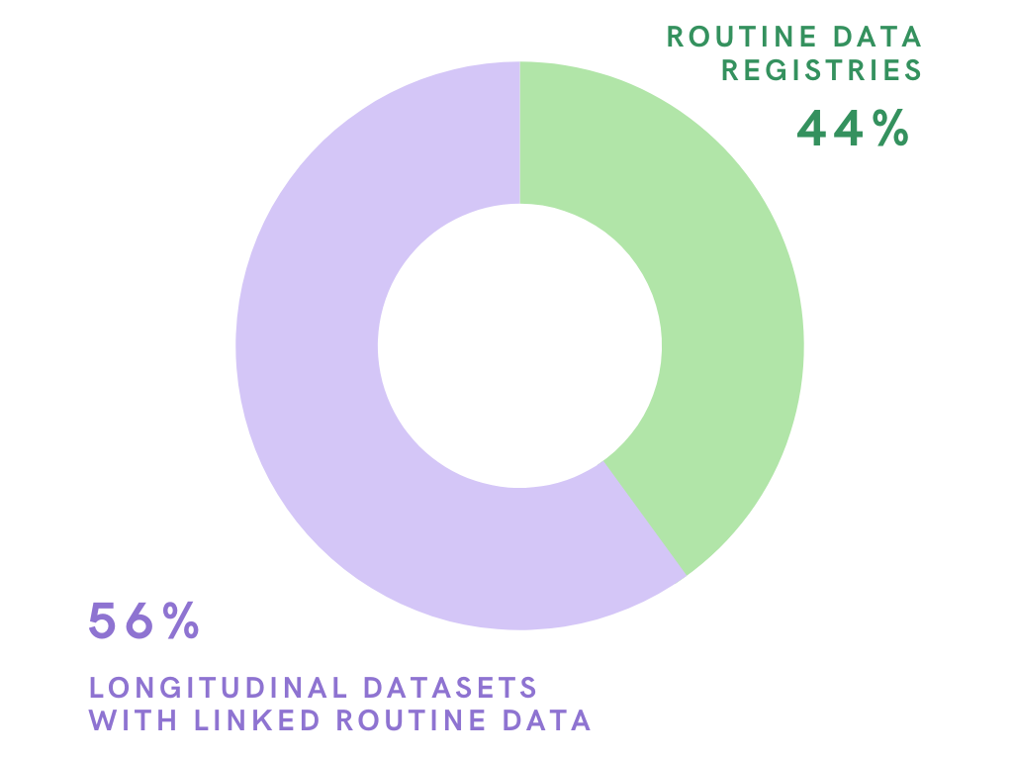

Figure 14. primary sources of data in datasets incorporating routinely collected data

4. Mental health embedded in wider context

Mental health within social context
Mental health conditions are often examined in a silo, without consideration for the wider context in which they develop. Cultural and social backgrounds provide valuable information for a better understanding of the trajectory of depression, anxiety and psychosis and potential targets for intervention.

In this pocket, we highlight 39 datasets that include measures of mental health in hand with detailed measurement of participants’ social context. Some of these datasets were household panel surveys (31%). While none of them were set up to examine mental health specifically, nearly half focused on socioeconomic conditions (38%) and a few closely examined physical health (10%).

In particular, several of these household panel surveys offer the opportunity to examine mental health in the context of family relationships and detailed socio-economic data in very large samples that are representative of the broader population. For example, the USA-based Panel Study of Income Dynamics Series (PSID), Understanding Society: the UK Household Longitudinal Survey (UKHLS), and the National Income Dynamics Study (NIDS) in South Africa have collected mental health data using questionnaire measures such as the Kessler Psychological Distress Scale (K6; Kessler et al., 2002) and GHQ-12 from tens of thousands of individuals across multiple decades. As these studies were designed to capture economic and social wellbeing, they also provide rich data on factors including household structure, poverty and income, education, labour market participation and social cohesion and offer opportunities for research on depression and anxiety within participants’ socioeconomic context.

The impact of the COVID-19 pandemic
For many, life has changed drastically during and after 2020. The COVID-19 pandemic transformed the usual ways of living and affected our physical, mental and social wellbeing (World Health Organisation, 2020). It may also have left lasting scars that researchers are still uncovering (O’Mahoney et al., 2023). Longitudinal datasets that were already established allowed researchers to gain rapid insight into the changes to mental health and wellbeing during this challenging time (Pierce et al. 2020).

In this pocket, we highlight 28 datasets with data for testing the impact of the pandemic on mental health and the long-lasting consequences of viral infection. These included existing datasets which incorporated data collection focused on experiences of the pandemic, and datasets established during the pandemic that are still ongoing. While a flurry of research was set up in response to the pandemic, only a few established datasets allow for comparisons with participants’ mental health prior to the pandemic. These datasets, most of which are based in Europe and the Americas, pre-dated the pandemic and conducted repeated data collection across 2020 and 2022, and have continued to collect data since then. For example, the British Birth Cohorts (National Survey of Health and Development (NSHD), born 1946; NCDS, born 1958; BCS70, born 1970; Next Steps, born 1989-90; Millennium Cohort Study (MCS), born 2000) co-ordinated three additional data collection waves during the pandemic, as well as COVID-19 antibody testing. These waves amassed questionnaire data on mental health, physical health, loneliness and social distancing practices using harmonised measures, providing the opportunity to investigate the consequences of the pandemic across different generations in the UK (Moreno-Agostino et al., 2022). Other established studies extracted sub-samples to measure the pandemic’s impact more closely. For example, the Dutch Lifelines study created the Lifelines COVID-19 cohort which has collected data on the psychological and societal impacts of the pandemic since March 2020.

A smaller number of studies were established during the pandemic and continue to assess the long-term effects of COVID-19, for example the Chilean Maternal-Infant Cohort Study-II in the COVID-19 Era (CHiMINCs-COVID) Study. The aim of the CHiMINCs-COVID study is to assess maternal dietary intake and mental health problems derived from the COVID-19 pandemic and their association with mothers’ and infants’ health and nutrition, providing essential information about long term consequences of the pandemic.

Connectivity between datasets
Datasets can exponentiate their value by joining forces with other similar or complementary initiatives. The development of consortia brings benefits to study teams and data users by harmonising instruments across different studies, facilitating research across multiple datasets, and maximising data availability.

In this pocket, we highlight 22 datasets that have strong links with other datasets or are part of consortia. Most datasets focus on physical health (38%), although a few have a mental health focus (19%). Several studies administered instruments designed to be comparable across sites and populations.

For example, the Ageing Trajectories of Health – Longitudinal Opportunities and Synergies (ATHLOS) project aims to understand the impact of ageing on health by harmonising core variables across studies. This consortium combines 17 cohorts from 38 countries using harmonised measures on health determinants and age-related events. Altogether, this initiative represents a sample of 411,000 individuals whose data covers multiple national contexts while offering substantial statistical power.

Another example is the Environmental and LifEstyle FActors iN metabolic health throughout life-course Trajectories (Project ELEFANT) that aims to investigate the effect of environmental exposures and lifestyle factors on the development of non-communicable diseases in China. It comprises five interconnected cohorts of people at different stages of life: Baby ELEFANT, Child and Adolescent ELEFANT, Young ELEFANT, Middle-aged ELEFANT, and Elderly ELEFANT. Participants transition from one project to the next as they grow older. The project collects data on various topics including smoking, drinking, psychological stress, individual and family disease history, pregnancy history, occupational exposures, menarche age and more. The integration of these different cohorts into one larger project aims to facilitate long-term follow-up of participants throughout their lives and an in-depth age-specific focus in each cohort.

In summary, while we found a few especially rich datasets for mental health research, we did not identify one perfect source of data. We noticed, however, groups of datasets that could complement each other and increase their value by joining forces.

Natural disasters and geopolitical factors
A few datasets offer unique opportunities to investigate mental health conditions related to natural disasters or political issues, in situ. This knowledge is especially important given the pervasive impact of climate change on mental health (Roberts et al., 2023) and political shifts in recent years.

In this pocket, we highlight 4 datasets with this distinctive potential, all of which focused on mental health. All but one of these datasets focused on childhood and early adolescence, with data also collected on caregivers in some instances.

Two studies focus on the psychological effects of war. The Afghanistan Mental Health and Childhood Adversities Study aims to establish baseline mental health data in a sample of 364 war-affected children and their caregivers. The study collected data on mental health over time, trauma, resilience, psychosocial suffering and everyday stressors using quantitative and qualitative methods. The Biological pathways of risk and resilience in Syrian refugee children (BIOPATH) cohort investigates the effect of biological and psychosocial factors on poor mental health. The sample was recruited from refugees living in informal settlements in Lebanon, having fled the war in Syria. Data were collected on well-being, mental health (depression, anxiety, and PTSD), sleep problems, impairment, behaviour problems, war exposure, psychosocial risk, coping strategies, family and community social context.

Two datasets examine the impact of natural disasters on mental health. The Wenchuan Earthquake Adolescent Health Cohort Study was created to investigate the effect of exposure to earthquakes on adolescents in Wenchuan, China. The cohort was surveyed on earthquake exposure, depressive symptoms, suicidality, and PTSD using a range of standard measures (e.g., Depression Self Rating Scale for Children (DSRSC; Birleson et al., 1987), Adolescent Self-Rating Life Events Check (ASLEC; Liu et al., 1997)). Participants were followed up ten years after the earthquake. The Stress in Pregnancy (SIP) Study was established to investigate how an adverse environment in utero affects foetal growth, development and life after delivery. Following Hurricane, or Superstorm, Sandy in the USA, the study followed a subsample of pregnant women to investigate how this natural disaster affected their offspring who were also followed after birth. Standard measures were used to collect data on stress, obstetric outcomes, biospecimens, traumatic stress, and psychopathology.

Interventions embedded in longitudinal datasets
Effective, evidence-based interventions are essential for addressing depression, anxiety and psychosis in the population. While testing the long-term effectiveness of all types of mental health interventions is of the utmost importance, the close focus of experimental designs can reduce the length of follow up, limiting evidence for the long-term impact of an intervention. Longitudinal designs with embedded intervention evaluations offer an opportunity to assess long-term impact through analyses of detailed data from both well before and long after the intervention.

In this pocket, we highlight 21 datasets with interventions embedded in their protocol. The majority are focused on mental health (81%). In addition to using trials within cohort designs, in recent years a number of cohorts have been set up to both track individuals over time and provide a resource to researchers recruiting participants to test the effectiveness of interventions (e.g., All of Us).

Some studies have embedded interventions into their study design. For example, Born in Bradford’s Better Start (BiBBS) is an experimental birth cohort of about 5,000 babies born in Bradford, England between 2016 and 2020. A total of 22 interventions have been implemented and will be evaluated by BiBBS to improve the outcomes of children in three deprived and ethnically diverse inner-city areas of Bradford. Multiple methods will be used to evaluate the interventions, including randomised clinical trials with randomly selected sub-samples of the cohort, as well as quasi-experimental methods when random allocation of families to an intervention is not feasible. Outcome measures will be collected via routine data collection using standard instruments (e.g., PHQ-9) and linked medical records (e.g., paediatrician visits).

Registries comprising service users’ healthcare data also offer the opportunity to observe the impact of care. Akrivia is a dataset of 4 million service user records for individuals receiving secondary mental health treatment from 17 NHS Trusts across the UK who utilise the CRIS System. It holds continuous data collection via linked health records and offers researchers the opportunity to recruit samples of participants to test interventions such as clinical trials for drug treatments, pathways and services.

Enrichment for the selected longitudinal datasets

Identifying datasets meeting the selection criteria
During the searching and identifying stages, the King’s College London team located 3,007 worldwide longitudinal datasets. A total of 86 datasets that met all four criteria relating to the number and age of participants, frequency of assessment and the possibility of recontacting participants, were retained for further review (list of datasets in the Appendix). Longitudinal datasets were not retained for further consideration most often because they did not include a minimum of 8,000 participants at inception and/or because participants were above the age of 30 (N=2,449, 81%). Of the remaining 558 datasets, 472 were excluded for a range of reasons such as not having collected mental health data between the ages of 14 and 30, having four or more years between data collection points, having ended more than three years ago, or because there was no publicly available information about the dataset.

Longitudinal datasets identified by the Open Data Institute were integrated at this stage, bringing the total pool of datasets meeting selection criteria to 100. The selected datasets covered all three geographical regions (Figure 15) but several countries in the Pacific, South America, Africa and the Middle East were not represented at this stage.

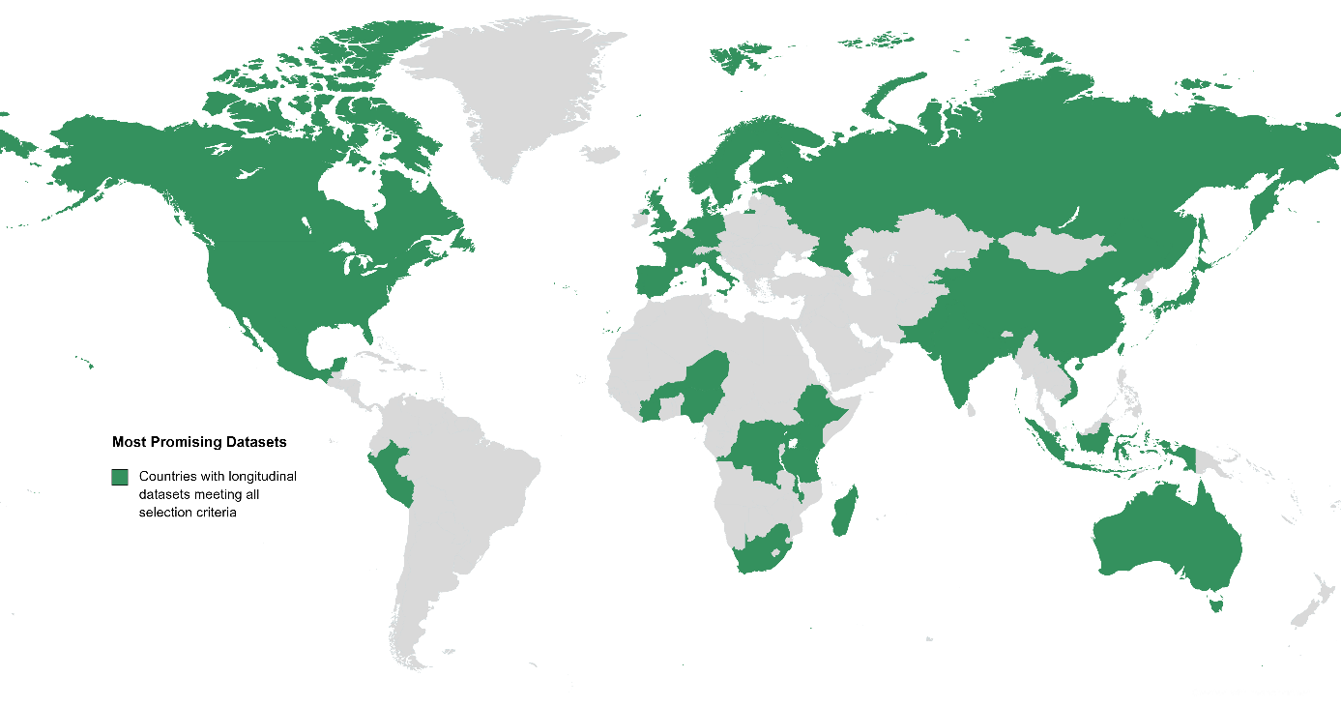
Figure 15. Countries with longitudinal datasets meeting all selection criteria
Note: Countries with identified longitudinal datasets meeting all selection criteria: Americas: Canada, Mexico, Peru, the United States of America; Africa, the Middle East & Asia: Bangladesh, Burkina Faso, China, Democratic Republic of Congo, Ethiopia, India, Indonesia, Japan, Kenya, Kyrgyzstan, Madagascar, Malawi, Nepal, Niger, Nigeria, Pakistan, Singapore, South Africa, South Korea, Taiwan, Tanzania, Vietnam; Europe & the Pacific: Australia, Denmark, England, France, Germany, Italy, Netherlands, Northern Ireland, Norway, Portugal, Russia, Scotland, Sweden, Wales
Of the 100 selected datasets, one in two focused on health and development and one in ten focused on mental health. Of these, eight datasets focused on the health of people working in specific occupations such as nurses, teachers or armed forces personnel, and two focused on collecting genetic data for health research. Other datasets focused on socio-economic conditions and wellbeing (N=23, 23%). Many of these datasets recruited cohorts of individuals (N=11, 11%) or used household panel designs (N=12, 12%). Datasets based on registry and routinely collected data that is particularly well-integrated with ongoing contact with participants were also retained (N=22, 22%).

We reviewed these 100 datasets in more depth to assess their value, with a view of describing areas of enrichment for transformative mental health research.

Our description for potential enrichment areas is informed and guided by three key elements: (1) the list of areas of enrichment provided by Wellcome’s RfP; (2) the outcomes of the ToC process capturing suggestions from different stakeholders, particularly LEEs; and (3) our experience of screening and reviewing more than 3,000 longitudinal datasets from around the world.

Below we provide a summary of the areas for enrichment that intersect across the datasets, grouped into four categories, and illustrated with examples of datasets. We do not discuss the implementation of strategies for enriching longitudinal datasets as it is beyond the scope of this project.

1. Preserve and expand targeted populations

Support retention to maintain representativeness of the data
A few datasets reported high participant retention after multiple years of data collection. This is essential for ensuring that datasets remain representative of the targeted populations, reducing bias and protecting the generalisability of the findings. However, the retention of participants in some datasets is under threat. A focus on recontacting lost participants with consideration for factors associated with early drop-out, such as income, education and parents’ age could limit attrition bias.

MoBa is used to illustrate this area of enrichment. About half of the participants still take part in the study (Vejrup et al., 2022) and sample retention is higher for families with parents who are older, live with a partner, have higher levels of education and income, are non-smokers, had planned pregnancies and used folic-acid supplements during pregnancy. This dataset could be enriched by recontacting lost participants, possibly using Norwegian personal identification numbers. This recontacting could prioritise factors such as parents’ age, income and education to reduce attrition bias. Further, as the cohort did not recruit parents who do not speak Norwegian, it is likely that immigrants and individuals from other marginalised groups, such as indigenous Sami are not included in the sample. An expansion of the targeted population involving recruiting participants who do not speak Norwegian could further broaden the representation of the Norwegian population in this dataset.

Diversify recruitment and improve retention of minoritised and marginalised participants
Minoritised and marginalised groups are not well represented in many datasets because of a range of historical, social and methodological factors including histories of discrimination in research (Scharff et al., 2010), limited outreach in recruitment (Jones et al., 2017; Thetford et al., 2021) and a lack of inclusive research practices (Fletcher-Watson et al., 2021). This is of particular concern as individuals from minoritised and marginalised groups, including LGBTQIA+ (Russell and Fish, 2016), ethnic/racial minorities (Halvorsrud et al., 2019), neurodivergent (Lai et al., 2019; Meinzer et al., 2014) and people experiencing homelessness (Fazel et al., 2014) are both at higher risk of experiencing mental health conditions and under-represented in longitudinal research unless they are specifically targeted during recruitment.

Several samples could be supplemented to become more inclusive of minority groups and ensure better representation of groups at high risk for experiencing mental health conditions. Targeted recruitment of minoritised and marginalised groups should address statistical considerations for allowing analyses examining ethnic inequalities.

Expand targeted population
Given the success of some datasets that recruited participants across different LMICs, expansion of the targeted population to other sites could be envisaged. The Young Lives Study illustrates this area for enrichment. Young Lives is an international prospective cohort study investigating the changing nature of childhood poverty in four low-income countries (Ethiopia, India, Peru, Vietnam) over a 20-year period. The study aims to deliver ground-breaking research that informs policy on how poverty, intersecting inequalities and new vulnerabilities affect the lives of disadvantaged children and young people and what can be done to improve their life outcomes. Using a sentinel site sampling approach, it recruited a younger cohort (aged between 6 and 18 months), and an older cohort of children (aged between 7 and 8 years old), at study inception in 2002. Attrition is below 6% for all four sites. Mental health data has been collected about the participants during childhood, adolescence and early adulthood using standard instruments. Mental health data has also been collected about participants’ biological mothers, fathers, primary caregivers and siblings.
Young Lives could be expanded in two ways: by recruiting samples in countries in Africa and South America that are not well represented in the selected datasets and by recruiting a new cohort of children in their early teens. This would allow international comparisons with participants of similar age in other datasets, and some in high-income countries.

A quote by Dr Natalie Darko for NHS England in 2023: “Research is fundamental to the delivery of high quality health care and should reflect the community for whose benefit the research is taking place. Failure to do so can impede our ability to generalise study results and identify appropriate interventions, contributing to widening healthcare inequalities.”

2. Improve measurement and collect new data

Support methodological work to test the comparability of mental health data for already collected measures in childhood
There is a wealth of existing mental health data across the longitudinal datasets, but the use of different instruments can hinder comparison across datasets, samples and regions. Mental health measurement varies across regions. For example, UK researchers have commonly used the Strengths and Difficulties Questionnaire (SDQ Info, 2022) to assess childhood mental health problems, which has been rarely taken up by researchers in the USA where the Child Behavior Checklist (CBCL; Achenbach, 1991) is more prevalent. Similarly, while International Classification of Diseases 10 (ICD-10; World Health Organisation, 2016) classifications dominate in European research (DSM-5; American Psychiatric Association, 2022), these criteria are not commonly used in the USA, Canada, Australia and New Zealand. These differences reflect local preferences and clinical practices but can curtail cross-regional comparison. To facilitate comparison across the datasets, methodological work could be undertaken to verify whether the already collected measures in childhood are suitably comparable.

Assess mental health conditions across diagnostic categories
Datasets used approaches to measuring mental health that adhere to traditional diagnostic categories which may not accurately reflect ‘real’ experiences of mental health conditions. Indeed, the symptoms, risk factors and outcomes of depression, anxiety and psychosis have more in common than the measures in most datasets can capture. The assessment of mental health conditions in longitudinal research should allow for disorder-focused analyses but also transdiagnostic approaches by including measures of a wide range of symptoms relevant to several disorders. This involves the use of scales for capturing a broad view of the experience of mental illness beyond diagnostic categories, along with the assessment of symptoms beyond those used for diagnosis of mental health conditions (e.g. sleep quality, impairment, functional outcomes). In addition, this would also involve consideration for impairment associated with disorders such as depression, anxiety, psychosis and also importantly, other mental health conditions.

Harmonise mental health measures to facilitate international comparison and discover the importance of social/cultural context
Harmonising data across instruments and across datasets is complex (Chow et al., 2023). However, there is a window of opportunity to collect prospectively harmonised mental health measures in a group of datasets in which participants are all currently transitioning to key developmental stages. Data harmonisation could be facilitated by including similar questions about mental health conditions across different studies. Harmonised measures across datasets from various regions will provide valuable findings about differences (or similarities) in mental health conditions across cultural and economic contexts. Datasets could include harmonised measures while retaining culturally appropriate and previously used measures. Indeed, it is of utmost importance to consider cultural context when assessing mental health and it is crucial to preserve previously used assessment methods for longitudinal analyses within each dataset.

Introduce regular assessment of early symptoms of psychosis via self-reports
Our analysis revealed an important gap in psychosis measurement, and especially early measurement, in studies with large sample sizes. Unless datasets have routinely collected health records, they have very few data to examine the development of psychosis from an early age. Furthermore, while linked data included in some datasets capture psychosis, these data are informative about psychosis after onset, missing out on key information concerning the development of this condition. New studies could include regular assessment of psychosis and experience of psychotic symptoms via self-reports to facilitate research that can examine the development and onset of psychosis.

In numbers:
- Over 3,000 longitudinal datasets were identified in the landscaping process
- 100 longitudinal datasets were large and ongoing with frequent assessment
- 1 in 10 of those large, ongoing datasets focused closely on mental health

Collect qualitative and climate change data
Two types of data could be added to several datasets. While quantitative data are useful for succinctly capturing information about mental health conditions, qualitative accounts of people's lived experience of mental health conditions are also a rich source of information. Few datasets have collected participants’ accounts of their experience of mental health conditions. Datasets could gather this valuable information as part of qualitative sub-studies. Furthermore, natural language processing could assist with exploring information contained in free-text electronic records.

The Resilience, Ethnicity & Adolescent Mental Health (REACH) study is an example of qualitative data collected as part of a longitudinal research study. REACH is a cohort of 4,000 adolescents from secondary schools in England that aims to investigate the occurrence, persistence and variation of mental health problems and the associated impact of social, psychological, and biological risk and protective factors in an ethnically diverse population. The study implemented qualitative interviews and video diaries with a sub-sample of their participants during a wave of data collection. This qualitative data collection captured participants’ experiences and psychological wellbeing during the COVID-19 pandemic in their own words, providing a rich source of data from participants’ perspectives.

In addition, most datasets have not collected information to test the possible impact of climate change on young people’s mental health. As the occurrence of climate change phenomena is increasingly more frequent, around the world, this may become an important risk factor for mental health conditions that studies could consider. Collecting data on climate change would improve research linked to two of Wellcome’s priority areas – mental health and climate change.

Consider collecting neuroimaging data to test the effect of interventions
Another gap revealed by our analysis is a lack of neuroimaging data capturing brain function. These data are rare because of the cost and practical issues associated with the equipment and technical expertise required to collect and process neuroimaging data. Indeed, none of the selected datasets offer the opportunity to examine the brain longitudinally across age periods when early key life events might affect mental health conditions. This would allow the examination of the link between early life events and brain development. The addition of neuroimaging data in some datasets could address this gap. This could be particularly valuable in longitudinal datasets with embedded interventions, where neuroimaging could be used to test the effect of treatment on the brain.

In summary, neuroimaging data embedded in longitudinal datasets have the potential to improve understanding of how brain, body and environment interact in the trajectory and resolution of depression, anxiety and psychosis.

3. Build infrastructure and facilitate connectivity

Build infrastructure to ensure datasets include important data related to mental health
We noticed that biological and linked routinely collected data are lacking in many datasets from outside Europe and North America. The lack of routinely collected health data may reflect the paucity of infrastructure in those countries and how health records are managed and stored in different contexts. While it may not be possible to change this, it is important to collect data about mental health conditions from multiple sources, especially when several members of a family are already involved in the research study. For biological data, and especially the collection of biospecimens that allow for genetic discoveries, it is important to develop and support infrastructure that can facilitate the collection of biological samples, such as PGC – Psychiatric Genomics Consortium and Taiwan Human Biology Database. We recognise that developing infrastructure involves important considerations related to law, policy and ethics. Furthermore, institutional strengthening in research management is required to facilitate a shift in the ‘centre of gravity’ of partnerships from high income countries in Europe and North America to LMICs.

Augment the discoverability and management of datasets
While it was relatively easy to find information about most datasets via websites and profile papers, some datasets are so rich that these resources can be difficult to navigate, and details are not always up to date. This limits the discoverability and, in turn, the effective use of these valuable datasets.

Efforts for increasing the discoverability of longitudinal datasets must consider the system in place for managing different data resources. Most datasets are managed internally. In these cases, it is important to invest in human resources to support the management of the datasets and preserve staff continuity for long lasting datasets. Alternatively, some datasets are managed by external organisations that improve discoverability and provide access to data. These types of organisations and consortia, such as the UK Data Service and DATAMIND, need continuous funding to sustain their work. If appropriate, another option would be to establish new data institutions aimed at improving access to data, and especially data outside academia.

Developing unified platforms to find information about datasets will also improve data discoverability and facilitate transformative mental health research. This is especially relevant for datasets based in LMICs where collaborations and interactions are more challenging and countries where language can be a barrier for accessing information and data (Academy of Science of South Africa & Academy of Medical Sciences, 2023). There could be major gains in making longitudinal datasets in LMICs and non-English speaking countries more discoverable for a more global appreciation of mental health conditions embedded in social and cultural contexts.

Develop connectivity between longitudinal datasets and with other data resources
Longitudinal datasets often work in silos, focusing on their particular aims, which can be broad and interdisciplinary (e.g., health, lifespan, behaviours). We could develop platforms to facilitate collaboration between leadership teams and work across longitudinal datasets for researchers. A good example of such initiatives is the UK Longitudinal Linkage Collaboration that aims to bring together information about longitudinal participants and their routine records.

Rather than overburdening study participants by collecting too many data too frequently to optimise the value of a single dataset, researchers and funders could consider coordinated efforts to optimise the value of groups of especially promising studies.

4. Promote LEE involvement, community engagement and service users’ input
Experts by experience must be an integral part of longitudinal mental health research, helping to design and develop studies from initiation to completion (Beames et al., 2021). Working with LEEs ensures research is relevant to people who have experienced mental health conditions and can support clinical work. For more details about how to implement LEE involvement in longitudinal research, see MQ report.

However, we found that very few large studies have worked with LEEs when developing their research programme. One possible explanation for this paucity of LEE involvement is that some of the selected datasets started in the early 2000s, prior to the relatively recent increase in awareness of the importance of LEEs in mental health research.

We identified productive and valuable collaboration with LEEs and communities that were implemented in two UK-based datasets, however. Born in Bradford (BiB) is a pregnancy cohort of 13,776 babies and their parents with strong LEE involvement and community engagement. BiB was established in 2007 to examine how genetic, nutritional, environmental, behavioural and social factors impact health and development during childhood, and subsequently adult life in a deprived multi-ethnic population. LE involvement takes place with both parents and young people involved in BiB. The BiB parent governors' group meets every two months and help to co-produce the research programme. Young people who are aged 11 to 12 years have been invited to become ‘Young Ambassadors’ and contribute their opinions, concerns and ideas about the BiB research as well as take part in discussions, projects and dissemination activities. Community involvement takes place through efforts to communicate and disseminate findings to BiB participants and the wider Bradford community using traditional methods (birthday cards, newsletters) and social media (community engagement), as well as regular events such as family science festivals and pop-up events in local shopping centres. There is also engagement with key stakeholders and the use of findings in local decision making to improve health both in the city and beyond.

Researchers based at Akrivia collaborated with a team of patients and members of the public to co-develop a model for the access of patient mental health records by researchers (Gibbons et al., 2023). While there can be scepticism and hesitation about the sharing of these data, the exercise revealed that transparency and involvement are highly valued by patients and the public when granting access to researchers. This highlights both good practice of a patient-centred approach and the value that patients and the public find in being part of the process that involves their information.

A quote from an interview with Grace Gatera and Shuranjeet Singh, Lived Experience Consultants at the Wellcome Trust in 2021: “I might have had many difficult life experiences, but that's not the value that my lived experience brings. What that brings is the knowledge, the insight.”

Conclusion

Concluding remarks
Following an extensive search for longitudinal datasets across the globe and across sectors, we provide a comprehensive review of the richness of mental health data. We also provide an in-depth analysis of a selection of the largest ongoing datasets to highlight innovative resources for researchers that can support transformative mental health research.

We discovered a wealth of longitudinal datasets and mental health data. Three areas of notable richness included datasets with strong measures of depression and anxiety, datasets with mental health data across the life course, and datasets with biological and genetic data. However, we also uncovered shortfalls in the mental health data available in very large datasets (especially for psychosis), the representativeness of targeted populations, and the involvement of LEEs in longitudinal research. We highlighted areas where enriching existing longitudinal datasets could improve and facilitate research that advances our understanding of mental health conditions, especially depression, anxiety and psychosis.

By presenting a summary of the strengths and opportunities for enrichment, our review highlights the potential for a coordinated approach to funding and sustaining longitudinal studies worldwide. While we found a few especially rich datasets for mental health research, we did not identify one perfect source of data. We noticed, however, groups of datasets that could complement each other and increase their value by joining forces. Rather than overburdening study participants by collecting too many data too frequently to optimise the value of a single dataset, researchers and funders could consider concerted efforts in optimising the value of groups of especially promising studies. This could allow rich datasets to prioritise certain aspects related to mental health without compromising participation rates and high-quality data.

We noted that few very large datasets focused on mental health. This could be reflecting a persistent lack of funding in mental health research relative to other health conditions (Woelbert et al., 2019; Wykes et al., 2015). This could also be due to challenges related to the measurement of mental health conditions across life and across cultures for providing an optimal account of people’s experiences. Reliable and strong measurement may be especially difficult to implement in research protocols targeting very large samples. However, maximising statistical power should not hinder the implementation of adequate measures of mental health conditions including age and culturally appropriate assessments and qualitative narrative accounts. We also observed that mental health measures were often added to large datasets several years after inception. Mental health assessment could be an integral part of large initiatives, from the very beginning and alongside other health topics, rather than being an afterthought.

While all geographical regions contributed several longitudinal datasets for this review, and also contributed richness for mental health research, we noticed disparity in assets. LMICs were under-represented and lacked resources for benefiting from technological developments (e.g., wearables, neuroimaging) or infrastructure (e.g., routinely collected data). This is not something that can be easily fixed as it will require shifts in perceptions, true commitment and huge investment to approach parity. Nonetheless, a few datasets from LMICs were especially rich with broad perspectives of mental health (e.g., multiple informants, qualitative data) and assessments embedded into a broader context (e.g., data on economic, educational and cultural environment).

We established a rigorous strategy from the start of the project to ensure we did not overlook any valuable datasets during our search. However, our methods are not without flaws. We cannot guarantee that we turned over every stone and we continued to find datasets until the end of the project. Yet, we remain confident we unearthed all relevant datasets for mental health research given our thorough search, our extensive networks of collaborators in the field and our prominent presence on social media where we disseminated the project beyond the UK and mental health research communities. We trust the high number of datasets we processed during this project is evidence of the effectiveness of our strategy for uncovering all longitudinal datasets worldwide. Nevertheless, below we explore possible gaps in our strategy.

In numbers, the proportion of longitudinal datasets identified from each geographical region was:
- 25% from North, Central and South America
- 25% from Africa, the Middle East and Asia
- 46% from Europe and the Pacific
- 4% from cross-regions
Our search for longitudinal datasets could have further explored fields outside mental health and in sectors beyond academia. While we identified several datasets that focused on physical health and economic factors, our outreach with the community of researchers in disciplines outside mental health was limited. For example, we noticed that study teams responsible for datasets on nurses or household panels, and datasets outside academia, were less likely to reply to our emails despite several follow ups. It is possible that they did not see the relevance of their datasets to this project on mental health.

Similarly, industry contacts that responded to initial emails were generally those with whom the ODI team already had close working relationships. First, no private providers of mental healthcare responded to the initial email. This is a potential source of data which could help significantly with furthering understanding of mental health, although the data are highly sensitive. However, public mental health care datasets were covered in the search. For example, any publicly funded mental health care provided in the UK or Denmark should be recorded in NHS or Danish registry datasets. Second, only one pharmaceutical company responded to the initial email, and this was not one considered to be a leader in mental health. We therefore cannot draw broad conclusions about the pharmaceutical industry. However, we have supplemented this with our own knowledge and desk research. Third, except for team members at Kooth, no app developers responded to the outreach emails, although some candidate datasets originating from apps were identified by our contacts, such as the ZOE Health Study. Data from mood-tracking apps, and data generated by wearables, could have significant potential in helping to understand mental health and, as such, this is a gap that ought to be addressed with further research.

Mapping the world for longitudinal datasets, and reviewing their value, is not an exact science. The estimates reported here are not definitive, but were instead meant to produce an appreciation of global resources for mental health research. Interpretation of this report should focus on relative rather than absolute values. Furthermore, our work may be biased by our own experience working in the field of mental health. While the selection criteria provided by Wellcome enabled us to narrow down our selection of datasets using specific and objective boundaries, richness and areas for enrichment were determined on a more holistic and subjective basis. However, we are reassured that the datasets in our pockets of value include high- and low-income countries and a range of geographical areas, focus on different topics and are based in different institutions. Further, our analysis of the richness of datasets and the areas for enrichment were informed and guided by the stakeholders who contributed to the ToC process, and especially LEEs (see MQ report).

Longitudinal research is not a fast-moving field but the relevance of this report is time-limited. While longitudinal research tends to build from years and years of committed investment and efforts, it is nonetheless a changing field with new initiatives regularly being set up to answer new innovative questions. Consequently, our mapping of longitudinal datasets will soon require updating. Our decision to make the list of 3,068 identified longitudinal datasets (as of May 2023) openly available on our website was not only driven by the importance of making these datasets more discoverable, but also by a wish to engage with the community of researchers to keep this list accurate and updated. While the conclusions from this report are unlikely to change anytime soon, longitudinal data resources may need amendment more rapidly.

A quote by Professor Miranda Wolpert MBE, Director of Mental Health at the Wellcome Trust: “When Wellcome commissioned King's College London, MQ Mental Health Research and the Open Data Institute to identify promising longitudinal datasets from around the world we did not know exactly what they would find. The identification of over 3,000 longitudinal datasets spanning 146 different countries marks a milestone in our understanding of what datasets are out there and how we might build on them going forward.”

Acknowledgements
We are grateful for the opportunity to explore so many rich data sources for mental health research and we are excited by Wellcome’s ambition to support excellence in longitudinal research in the future.

We want to thank Matthew Brown, Technology Lead at the Wellcome Trust, Suzanne Gage and Ines Pote from Wellcome’s Mental Health Team and Lorraine Holland, Programme Officer for their guidance, support and enthusiasm throughout this project.

We are grateful to the people who contributed to the ToC workshop for their interest, insight and extremely valuable comments.

We also want to thank numerous people who contributed time, knowledge, and expertise to the various stages of this project and its dissemination.

Glossary
ASRM | Altman Self-Rating Mania Scale
BMJ | British Medical Journal
CAPS-5 | Clinician Administered PTSD Scale for DSM-5
CBCL | Child Behavior Checklist
CBQ | Child Behaviour Questionnaire
CGMH | Centre for Global Mental Health
CIS-R | Clinical Interview Schedule-Revised
CIDI | Composite International Diagnostic Interview
CLOSER | Cohort and Longitudinal Studies Enhancement Resources
COVID-19 | Coronavirus disease
DASS-21 | Depression Anxiety Stress Scale Short Form
DSM-5 | The Diagnostic and Statistical Manual of Mental Disorders, 5th Edition
DISC-IV | Diagnostic Interview Schedule for Children-IV
DNA | Deoxyribonucleic acid
DTI | Diffusion tensor imaging
EEG | Electroencephalogram
EOI | Expression of Interest
EPDS | Edinburgh Postnatal Depression Scale
FAQ | Frequently asked questions
fMRI | Functional magnetic resonance imaging
GAD-7 | Generalized Anxiety Disorder Assessment – 7-item
GHQ-12 | General Health Questionnaire – 12-item
GP | General Practitioner
HIV/AIDS | Human immunodeficiency virus/Acquired immune deficiency syndrome
ICD-10 | International Classification of Diseases, Tenth Revision
IoPPN | Institute of Psychiatry, Psychology and Neuroscience
K6 | Kessler Psychological Distress Scale – 6-item
KCL | King’s College London
K-SADS-5 | Kiddie Schedule for Affective Disorders and Schizophrenia – revised for DSM-5
LE | Lived experience
LEE(s) | Lived experience expert(s)
LGBTQIA+ | Lesbian, gay, bisexual, transgender, queer/questioning, intersex, asexual, and more
LMIC(s) | Low- and middle- income country/ies
MASQ | Mini-Mood and Anxiety Symptom Questionnaire
MH | Mental health
Middle East | Countries geographically located between Africa and Asia (not a political distinction)
MRA | Magnetic resonance angiography
MRC | Medical Research Council
MRI | Magnetic resonance imaging
MQ | MQ Mental Health Research
NHS | National Health Service, the UK public health system
NIH | National Institutes of Health
NIMH | National Institute of Mental Health
OCD | Obsessive-compulsive disorder
ODI | Open Data Institute
PCL-6 | PTSD Checklist for DSM-5, 6 question
PGC | Psychiatric Genomics Consortium
PLoS | Public Library of Science
PHQ-9 | Patient Health Questionnaire – 9-item
PI(s) | Principal investigator(s)
PRISMA | Preferred Reporting Items for Systematic Reviews and Meta-Analyses
PTSD | Post-traumatic stress disorder
Q&A | Question and answer
RfP | Request for Proposal
SDQ | Strengths and Difficulties Questionnaire
SES | Socio-economic status
SF-12 | Short Form Health Questionnaire – 12-item
sMFQ | Short Mood and Feelings Questionnaire
ToC | Theory of Change
UK | United Kingdom
USA | United States of America
WHO | World Health Organisation
WHO-5 | World Health Organisation - Five Well-Being Index
Wellcome/WT | The Wellcome Trust

References
Academy of Science of South Africa, & Academy of Medical Sciences. (2023). Advancing multisectoral and life-course approaches in mental health research: Workshop report. https://research.assaf.org.za/handle/20.500.11911/320
Achenbach, T. M. (1991). Manual for the Child Behavior Checklist/4-18 and 1991 Profile. Department of Psychiatry, University of Vermont.
Altman, E. G., Hedeker, D., Peterson, J. L., & Davis, J. M. (1997). The Altman Self-Rating Mania Scale. Biological Psychiatry, 42(10), 948–955. https://doi.org/10.1016/S0006-3223(96)00548-3
American Psychiatric Association. (2022). Diagnostic and Statistical Manual of Mental Disorders (5th ed., text rev.). DSM Library. https://dsm.psychiatryonline.org/doi/book/10.1176/appi.books.9780890425787
Angold, A., Costello, E. J., Messer, S. C., & Pickles, A. (1995). Development of a short questionnaire for use in epidemiological studies of depression in children and adolescents. International Journal of Methods in Psychiatric Research, 5(4), 237–249.
Arias, D., Saxena, S., & Verguet, S. (2022). Quantifying the global burden of mental disorders and their economic value. EClinicalMedicine, 54. https://doi.org/10.1016/j.eclinm.2022.101675
Ask, H., Cheesman, R., Jami, E. S., Levey, D. F., Purves, K. L., & Weber, H. (2021). Genetic contributions to anxiety disorders: where we are and where we are heading. Psychological Medicine, 51(13), 2231-2246. https://doi.org/10.1017/S0033291720005486
Beames, J. R., Kikas, K., O’Gradey-Lee, M., Gale, N., Werner-Seidler, A., Boydell, K. M., & Hudson, J. L. (2021). A New Normal: Integrating Lived Experience Into Scientific Data Syntheses. Frontiers in Psychiatry, 12, e763005. https://doi.org/10.3389/fpsyt.2021.763005
Bentley, A. R., Callier, S., & Rotimi, C. N. (2017). Diversity and inclusion in genomic research: why the uneven progress?. Journal of Community Genetics, 8, 255-266. https://doi.org/10.1007/s12687-017-0316-6
Birleson, P., Hudson, I., Buchanan, D. G., & Wolff, S. (1987). Clinical evaluation of a self‐rating scale for depressive disorder in childhood (Depression Self‐Rating Scale). Journal of Child Psychology and Psychiatry, 28(1), 43-60. https://doi.org/10.1111/j.1469-7610.1987.tb00651.x
Breuer, E., De Silva, M. J., Fekadu, A., Luitel, N. P., Murhar, V., Nakku, J., Petersen, I., & Lund, C. (2014). Using workshops to develop theories of change in five low and middle income countries: Lessons from the programme for improving mental health care (PRIME). International Journal of Mental Health Systems, 8(1), 15. https://doi.org/10.1186/1752-4458-8-15
Breuer, E., De Silva, M. J., Shidaye, R., Petersen, I., Nakku, J., Jordans, M. J. D., Fekadu, A., & Lund, C. (2016). Planning and evaluating mental health services in low- and middle-income countries using theory of change. The British Journal of Psychiatry, 208(Suppl 56), s55–s62. https://doi.org/10.1192/bjp.bp.114.153841
Caspi, A., Houts, R. M., Ambler, A., Danese, A., Elliott, M. L., Hariri, A., Harrington, H., Hogan, S., Poulton, R., Ramrakha, S., Rasmussen, L. J. H., Reuben, A., Richmond-Rakerd, L., Sugden, K., Wertz, J., Williams, B. S., & Moffitt, T. E. (2020). Longitudinal assessment of mental health disorders and comorbidities across 4 decades among participants in the Dunedin Birth Cohort Study. JAMA Network Open, 3(4), e203221. https://doi.org/10.1001/jamanetworkopen.2020.3221
Chow, S. M., Nahum-Shani, I., Baker, J. T., Spruijt-Metz, D., Allen, N. B., Auerbach, R. P., Dunton, G. F., Friedman, N. P., Intille, S. S., Klasnja, P., Marlin, B., Nock, M. K., Rauch, S. L., Pavel, M., Vrieze, S., Wetter, D. W., Kleiman, E. M., Brick, T. R., Perry, H., … & Intensive Longitudinal Health Behavior Network (ILHBN). (2023). The ILHBN: Challenges, opportunities, and solutions from harmonizing data under heterogeneous study designs, target populations, and measurement protocols. Translational Behavioral Medicine, 13(1), 7–16. https://doi.org/10.1093/tbm/ibac069
Cox, J. L., Holden, J. M., & Sagovsky, R. (1987). Detection of Postnatal Depression: Development of the 10-item Edinburgh Postnatal Depression Scale. The British Journal of Psychiatry, 150(6), 782–786. https://doi.org/10.1192/bjp.150.6.782
De Silva, M. J., Breuer, E., Lee, L., Asher, L., Chowdhary, N., Lund, C., & Patel, V. (2014). Theory of Change: A theory-driven approach to enhance the Medical Research Council’s framework for complex interventions. Trials, 15(1), 267. https://doi.org/10.1186/1745-6215-15-267
De Stavola, B. L., Herle, M., & Pickles, A. (2022). Framing causal questions in life course epidemiology. Annual Review of Statistics and Its Application, 9, 223-248. https://doi.org/10.1146/annurev-statistics-040120-024748
Fazel, S., Geddes, J. R., & Kushel, M. (2014). The health of homeless people in high-income countries: Descriptive epidemiology, health consequences, and clinical and policy recommendations. The Lancet, 384(9953), 1529–1540. https://doi.org/10.1016/S0140-6736(14)61132-6
Fletcher-Watson, S., Brook, K., Hallett, S., Murray, F., & Crompton, C. J. (2021). Inclusive Practices for Neurodevelopmental Research. Current Developmental Disorders Reports, 8(2), 88–97. https://doi.org/10.1007/s40474-021-00227-z
Gameiro, G. R., Sinkunas, V., Liguori, G. R., & Auler-Júnior, J. O. C. (2018). Precision Medicine: Changing the way we think about healthcare. Clinics, 73, e723. https://doi.org/10.6061/clinics/2017/e723
Gibbons, S., Kontari, P., Pillinger, S., Ford, E., & Fell, B. (2023, April 26). Patient and Public Involvement Co-Development of a Route to Record-Level Data Access to Akrivia Health’s Secondary Healthcare Dataset: A patient-centred approach to mental health medical data access [Poster presentation]. MQ Data Science Meeting 2023.
Goldberg, D. P., & Hillier, V. F. (1979). A scaled version of the General Health Questionnaire. Psychological Medicine, 9(1), 139–145. https://doi.org/10.1017/s0033291700021644
Goodman, R. (1997). The Strengths and Difficulties Questionnaire: A Research Note. Journal of Child Psychology and Psychiatry, 38(5), 581–586. https://doi.org/10.1111/j.1469-7610.1997.tb01545.x
Hagenbeek, F. A., Hirzinger, J. S., Breunig, S., Bruins, S., Kuznetsov, D. V., Schut, K., Odintsova, V. V., & Boomsma, D. I. (2023). Maximizing the value of twin studies in health and behaviour. Nature Human Behaviour, 1–12. https://doi.org/10.1038/s41562-023-01609-6
Halvorsrud, K., Nazroo, J., Otis, M., Brown Hajdukova, E., & Bhui, K. (2019). Ethnic inequalities in the incidence of diagnosis of severe mental illness in England: A systematic review and new meta-analyses for non-affective and affective psychoses. Social Psychiatry and Psychiatric Epidemiology, 54(11), 1311–1323. https://doi.org/10.1007/s00127-019-01758-y
Harvey, S. B., Modini, M., Joyce, S., Milligan-Saville, J. S., Tan, L., Mykletun, A., Bryant, R. A., Christensen, H., & Mitchell, P. B. (2017). Can work make you mentally ill? A systematic meta-review of work-related risk factors for common mental health problems. Occupational and Environmental Medicine, 74(4), 301–310. https://doi.org/10.1136/oemed-2016-104015
Henry, J. D., & Crawford, J. R. (2005). The short-form version of the Depression Anxiety Stress Scales (DASS-21): Construct validity and normative data in a large non-clinical sample. The British Journal of Clinical Psychology, 44(2), 227–239. https://doi.org/10.1348/014466505X29657
Hoppen, T. H., Priebe, S., Vetter, I., & Morina, N. (2021). Global burden of post-traumatic stress disorder and major depression in countries affected by war between 1989 and 2019: A systematic review and meta-analysis. BMJ Global Health, 6(7), e006303. https://doi.org/10.1136/bmjgh-2021-006303
Jones, B.L., Vyhlidal, C.A., Bradley-Ewing, A., Sherman, A., & Goggin, K. (2017). If we would only ask: How Henrietta Lacks continues to teach us about perceptions of research and genetic research among African Americans today. Journal of Racial and Ethnic Health Disparities, 4, 735–745. https://doi.org/10.1007/s40615-016-0277-1
Jongsma, H. E., Turner, C., Kirkbride, J. B., & Jones, P. B. (2019). International incidence of psychotic disorders, 2002-17: A systematic review and meta-analysis. The Lancet. Public Health, 4(5), e229–e244. https://doi.org/10.1016/S2468-2667(19)30056-8
Joshi, H. (2016). Why do we need longitudinal survey data? IZA World of Labor. https://doi.org/10.15185/izawol.308
Kaufman, J., & Schweder, A. E. (2004). The Schedule for Affective Disorders and Schizophrenia for School-Age Children: Present and Lifetime version (K-SADS-PL). In Comprehensive handbook of psychological assessment, Vol. 2: Personality assessment (pp. 247–255). John Wiley & Sons, Inc.
Kaufman, J., Birmaher, B., Axelson, D., Perepletchikova, F., Brent, D., & Ryan, N. (2016). Kiddie Schedule for Affective Disorders and Schizophrenia (revised for DSM-5 diagnoses) (K-SADS-PL DSM-5). Advanced Center for Intervention and Services Research (ACISR) for Early Onset Mood and Anxiety Disorders (Western Psychiatric Institute and Clinic) & Child and Adolescent Research and Education (CARE) Program (Yale University). https://www.pediatricbipolar.pitt.edu/sites/default/files/KSADS_DSM_5_SCREEN_Final.pdf
Kendall, K. M., Van Assche, E., Andlauer, T. F. M., Choi, K. W., Luykx, J. J., Schulte, E. C., & Lu, Y. (2021). The genetic basis of major depression. Psychological Medicine, 51(13), 2217-2230. https://doi.org/10.1017/S0033291721000441
Kessler, R. C., Andrews, G., Colpe, L. J., Hiripi, E., Mroczek, D. K., Normand, S. L. T., Walters, E. E., & Zaslavsky, A. M. (2002). Short screening scales to monitor population prevalences and trends in non-specific psychological distress. Psychological Medicine, 32(6), 959–976. https://doi.org/10.1017/S0033291702006074
Kroenke, K., Spitzer, R. L., & Williams, J. B. W. (2001). The PHQ-9. Journal of General Internal Medicine, 16(9), 606–613. https://doi.org/10.1046/j.1525-1497.2001.016009606.x
Lai, M.-C., Kassee, C., Besney, R., Bonato, S., Hull, L., Mandy, W., Szatmari, P., & Ameis, S. H. (2019). Prevalence of co-occurring mental health diagnoses in the autism population: A systematic review and meta-analysis. The Lancet Psychiatry, 6(10), 819–829. https://doi.org/10.1016/S2215-0366(19)30289-5
Lang, A. J., & Stein, M. B. (2005). An abbreviated PTSD checklist for use as a screening instrument in primary care. Behaviour Research and Therapy, 43(5), 585–594. https://doi.org/10.1016/j.brat.2004.04.005
Lawlor, D. A., Tilling, K., & Davey Smith, G. (2016). Triangulation in aetiological epidemiology. International Journal of Epidemiology, 45(6), 1866–1886. https://doi.org/10.1093/ije/dyw314
Lawrence, P. J., Murayama, K., & Creswell, C. (2019). Systematic review and meta-analysis: Anxiety and depressive disorders in offspring of parents with anxiety disorders. Journal of the American Academy of Child and Adolescent Psychiatry, 58(1), 46–60. https://doi.org/10.1016/j.jaac.2018.07.898
Legge, S. E., Santoro, M. L., Periyasamy, S., Okewole, A., Arsalan, A., & Kowalec, K. (2021). Genetic architecture of schizophrenia: a review of major advancements. Psychological Medicine, 51(13), 2168-2177. https://doi.org/10.1017/S0033291720005334
Liu, X., Liu, L., Yang, J., Chai, F., Wang, A., Sun, L., Zhao, G., & Ma, D. (1997). The Adolescent Self-Rating Life Events Checklist and its reliability and validity. Chinese Journal of Clinical Psychology, 5(1), 34-36.
McFarlane, A. C., & Bryant, R. A. (2007). Post-traumatic stress disorder in occupational settings: Anticipating and managing the risk. Occupational Medicine, 57(6), 404–410. https://doi.org/10.1093/occmed/kqm070
McKay, M. T., Cannon, M., Chambers, D., Conroy, R. M., Coughlan, H., Dodd, P., Healy, C., O’Donnell, L., & Clarke, M. C. (2021). Childhood trauma and adult mental disorder: A systematic review and meta-analysis of longitudinal cohort studies. Acta Psychiatrica Scandinavica, 143(3), 189–205. https://doi.org/10.1111/acps.13268
Meinzer, M. C., Pettit, J. W., & Viswesvaran, C. (2014). The co-occurrence of attention-deficit/hyperactivity disorder and unipolar depression in children and adolescents: A meta-analytic review. Clinical Psychology Review, 34(8), 595–607. https://doi.org/10.1016/j.cpr.2014.10.002
Milne, B. J., D'Souza, S., Andersen, S. H., & Richmond-Rakerd, L. S. (2022). Use of Population-Level Administrative Data in Developmental Science. Annual Review of Developmental Psychology, 4, 447-468. https://doi.org/10.1146/annurev-devpsych-120920-023709
Moreno-Agostino, D., Fisher, H. L., Hatch, S. L., Morgan, C., Ploubidis, G. B., & Das-Munshi, J. (2022). Generational, sex, and socioeconomic inequalities in mental and social wellbeing during the COVID-19 pandemic: Prospective longitudinal observational study of five UK cohorts. Psychological Medicine, 1–12. https://doi.org/10.1017/S0033291722003348
NHS Digital. (2022). Mental Health of Children and Young People in England 2022—Wave 3 follow up to the 2017 survey. NDRS. https://digital.nhs.uk/data-and-information/publications/statistical/mental-health-of-children-and-young-people-in-england/2022-follow-up-to-the-2017-survey
O’Mahoney, L. L., Routen, A., Gillies, C., Ekezie, W., Welford, A., Zhang, A., Karamchandani, U., Simms-Williams, N., Cassambai, S., Ardavani, A., Wilkinson, T. J., Hawthorne, G., Curtis, F., Kingsnorth, A. P., Almaqhawi, A., Ward, T., Ayoubkhani, D., Banerjee, A., Calvert, M., … & Khunti, K. (2023). The prevalence and long-term health effects of Long Covid among hospitalised and non-hospitalised populations: A systematic review and meta-analysis. EClinicalMedicine, 55, e101762. https://doi.org/10.1016/j.eclinm.2022.101762

Pierce, M., Hope, H., Ford, T., Hatch, S., Hotopf, M., John, A., Kontopantelis, E., Webb, R., Wessely, S., McManus, S., & Abel, K. M. (2020). Mental health before and during the COVID-19 pandemic: A longitudinal probability sample survey of the UK population. The Lancet Psychiatry, 7(10), 883–892. https://doi.org/10.1016/S2215-0366(20)30308-4
Pingault, J. B., O’Reilly, P. F., Schoeler, T., Ploubidis, G. B., Rijsdijk, F., & Dudbridge, F. (2018). Using genetic data to strengthen causal inference in observational research. Nature Reviews Genetics, 19(9), 566-580. https://doi.org/10.1038/s41576-018-0020-3
Ramphul, K. (2018). Mauritius needs to address mental illness, starting in schools. The Lancet Psychiatry, 5(10), 786–787. https://doi.org/10.1016/S2215-0366(18)30304-3
Richards, J. S., Hartman, C. A., Ormel, J., & Oldehinkel, A. J. (2022). Continuity of psychopathology throughout adolescence and young adulthood. Journal of Clinical Child & Adolescent Psychology, 1-14. https://doi.org/10.1080/15374416.2022.2042695
Roberts, M., Colley, K., Currie, M., Eastwood, A., Li, K. H., Avery, L. M., Beevers, L. C., Braithwaite, I., Dallimer, M., Davies, Z. G., Fisher, H. L., Gidlow, C. J., Memon, A., Mudway, I. S., Naylor, L. A., Reis, S., Smith, P., Stansfeld, S. A., Wilkie, S., & Irvine, K. N. (2023). The contribution of environmental science to mental health research: A scoping review. International Journal of Environmental Research and Public Health, 20(7), 5278. https://doi.org/10.3390/ijerph20075278
Robins, L. N., Wing, J., Wittchen, H. U., Helzer, J. E., Babor, T. F., Burke, J., Farmer, A., Jablenski, A., Pickens, R., Regier, D. A., Sartorius, N., & Towle, L. H. (1988). The Composite International Diagnostic Interview: An Epidemiologic Instrument Suitable for Use in Conjunction With Different Diagnostic Systems and in Different Cultures. Archives of General Psychiatry, 45(12), 1069–1077. https://doi.org/10.1001/archpsyc.1988.01800360017003
Rodgers, B., Pickles, A., Power, C., Collishaw, S., & Maughan, B. (1999). Validity of the Malaise Inventory in general population samples. Social Psychiatry and Psychiatric Epidemiology, 34(6), 333–341. https://doi.org/10.1007/s001270050153
Rothbart, M. K., Ahadi, S. A., Hershey, K. L., & Fisher, P. (2001). Investigations of temperament at three to seven years: The Children’s Behavior Questionnaire. Child Development, 72(5), 1394–1408. https://doi.org/10.1111/1467-8624.00355
Russell, S. T., & Fish, J. N. (2016). Mental Health in Lesbian, Gay, Bisexual, and Transgender (LGBT) Youth. Annual Review of Clinical Psychology, 12(1), 465–487. https://doi.org/10.1146/annurev-clinpsy-021815-093153
Rutter, M. (1994). Beyond longitudinal data: Causes, consequences, changes, and continuity. Journal of Consulting and Clinical Psychology, 62, 928–940. https://doi.org/10.1037/0022-006X.62.5.928
Scharff, D.P., Mathews, K.J., Jackson, P., Hoffsuemmer, J., Martin, E., Edwards, D. (2010). More than Tuskegee: Understanding mistrust about research participation. Journal of Health Care for the Poor and Underserved, 21(3), 879-97. https://doi.10.1353/hpu.0.0323
Schoeler, T., Speed, D., Porcu, E., Pirastu, N., Pingault, J. B., & Kutalik, Z. (2023). Participation bias in the UK Biobank distorts genetic associations and downstream analyses. Nature Human Behaviour, 1-12. https://doi.org/10.1038/s41562-023-01579-9
SDQ Info. (2022). What is the SDQ? https://www.sdqinfo.org/a0.html
Shaffer, D., Fisher, P., Lucas, C. P., Dulcan, M. K., & Schwab-Stone, M. E. (2000). NIMH Diagnostic Interview Schedule for Children Version IV (NIMH DISC-IV): Description, differences from previous versions, and reliability of some common diagnoses. Journal of the American Academy of Child and Adolescent Psychiatry, 39(1), 28–38. https://doi.org/10.1097/00004583-200001000-00014
Smart, A., & Harrison, E. (2017). The under-representation of minority ethnic groups in UK medical research. Ethnicity & Health, 22(1), 65–82. https://doi.org/10.1080/13557858.2016.1182126
Smith Jervelund, S., & De Montgomery, C. J. (2020). Nordic registry data: Value, validity and future. Scandinavian Journal of Public Health, 48(1), 1–4. https://doi.org/10.1177/1403494819898573
Solmi, M., Radua, J., Olivola, M., Croce, E., Soardo, L., Salazar de Pablo, G., Il Shin, J., Kirkbride, J. B., Jones, P., Kim, J. H., Kim, J. Y., Carvalho, A. F., Seeman, M. V., Correll, C. U., & Fusar-Poli, P. (2022). Age at onset of mental disorders worldwide: Large-scale meta-analysis of 192 epidemiological studies. Molecular Psychiatry, 27(1), https://doi.org/10.1038/s41380-021-01161-7
Spitzer, R. L., Kroenke, K., Williams, J. B. W., & Löwe, B. (2006). A brief measure for assessing generalized anxiety disorder: The GAD-7. Archives of Internal Medicine, 166(10), 1092–1097. https://doi.org/10.1001/archinte.166.10.1092
Subramaniam, K., Krishnaswamy, S., Jemain, A. A., Hamid, A., & Patel, V. (2006). The Clinical Interview Schedule-Revised (CIS-R)–Malay Version, Clinical Validation. The Malaysian Journal of Medical Sciences: MJMS, 13(1), 58–62.
Sylvia, L. G., Montana, R. E., Deckersbach, T., Thase, M. E., Tohen, M., Reilly-Harrington, N., McInnis, M. G., Kocsis, J. H., Bowden, C., Calabrese, J., Gao, K., Ketter, T., Shelton, R. C., McElroy, S. L., Friedman, E. S., Rabideau, D. J., & Nierenberg, A. A. (2017). Poor quality of life and functioning in bipolar disorder. International Journal of Bipolar Disorders, 5(1), 10. https://doi.org/10.1186/s40345-017-0078-4
Thetford, K., Gillespie, T.W., Kim, Y.I., Hansen, B., Scarinci, I.C. (2021). Willingness of Latinx and African Americans to participate in nontherapeutic trials: It depends on who runs the research. Ethnicity & Disease, 31(2), 263-272. https://doi.org/10.18865/ed.31.2.263.
Topp, C. W., Østergaard, S. D., Søndergaard, S., & Bech, P. (2015). The WHO-5 Well-Being Index: A Systematic Review of the Literature. Psychotherapy and Psychosomatics, 84(3), 167–176. https://doi.org/10.1159/000376585
Treasure, J., Duarte, T. A., & Schmidt, U. (2020). Eating disorders. The Lancet, 395(10227), 899–911. https://doi.org/10.1016/S0140-6736(20)30059-3
Vejrup, K., Magnus, P., & Magnus, M. (2022). Lost to follow-up in the Norwegian mother, father and child cohort study. Paediatric and Perinatal Epidemiology, 36(2), 300–309. https://doi.org/10.1111/ppe.12821
Visser, K., Bolt, G., Finkenauer, C., Jonker, M., Weinberg, D., & Stevens, G. W. J. M. (2021). Neighbourhood deprivation effects on young people’s mental health and well-being: A systematic review of the literature. Social Science & Medicine, 270, 113542. https://doi.org/10.1016/j.socscimed.2020.113542
Ware, J. E., Kosinski, M., & Keller, S. D. (1996). A 12-Item Short-Form Health Survey: Construction of Scales and Preliminary Tests of Reliability and Validity. Medical Care, 34(3), 220.
Watson, D., Weber, K., Assenheimer, J. S., Clark, L. A., Strauss, M. E., & McCormick, R. A. (1995a). Testing a tripartite model: I. Evaluating the convergent and discriminant validity of anxiety and depression symptom scales. Journal of Abnormal Psychology, 104(1), 3–14. https://doi.org/10.1037/0021-843X.104.1.3
Watson, D., Clark, L. A., Weber, K., Assenheimer, J. S., Strauss, M. E., & McCormick, R. A. (1995b). Testing a tripartite model: II. Exploring the symptom structure of anxiety and depression in student, adult, and patient samples. Journal of Abnormal Psychology, 104(1), 15–25. https://doi.org/10.1037/0021-843X.104.1.15
Weathers, F. W., Bovin, M. J., Lee, D. J., Sloan, D. M., Schnurr, P. P., Kaloupek, D. G., Keane, T. M., & Marx, B. P. (2018). The Clinician-Administered PTSD Scale for DSM–5 (CAPS-5): Development and Initial Psychometric Evaluation in Military Veterans. Psychological Assessment, 30(3), 383–395. https://doi.org/10.1037/pas0000486
Woelbert, E., Kirtley, A., Balmer, N. & Dix, S. (2019). How much is spent on mental health research: Developing a system for categorising grant funding in the UK. Lancet Psychiatry, 6, 445-452. http://dx.doi.org/10.1016/S2215-0366(19)30033-1

Wolke, D., Waylen, A., Samara, M., Steer, C., Goodman, R., Ford, T., & Lamberts, K. (2009). Selective drop-out in longitudinal studies and non-biased prediction of behaviour disorders. The British Journal of Psychiatry, 195(3), 249–256. https://doi.org/10.1192/bjp.bp.108.053751
Wolpert, M., Bilsland, L., Boyce, N., Martin, K., & Sebastian, C. (2023). The Wellcome Trust: New funding for mental health science. World Psychiatry, 22(2), 234–235. https://doi.org/10.1002/wps.21077
World Bank. (2023). Why are some data not available? – World Bank Data Help Desk. https://datahelpdesk.worldbank.org/knowledgebase/articles/191133-why-are-some-data-not-available
World Health Assembly. (2012). Global burden of mental disorders and the need for a comprehensive, coordinated response from health and social sectors at the country level: Report by the Secretariat (A65/10). World Health Organisation. https://apps.who.int/iris/handle/10665/78898
World Health Organization. Regional Office for Europe. (1998). Wellbeing measures in primary health care/the DepCare Project: Report on a WHO meeting: Stockholm, Sweden, 12–13 February 1998 (WHO/EURO:1998-4234-43993-62027). World Health Organization. Regional Office for Europe. https://apps.who.int/iris/handle/10665/349766
World Health Organisation. (2016). International Statistical Classification of Diseases and Related Health Problems (10th ed.). https://icd.who.int/browse10/2016/en
World Health Organisation. (2017a). Depression and other common mental disorders: Global health estimates (WHO/MSD/MER/2017.2). World Health Organisation. https://apps.who.int/iris/handle/10665/254610
World Health Organisation. (2017b). Ageing and health. https://www.who.int/news-room/fact-sheets/detail/ageing-and-health
World Health Organisation. (2020). Impact of COVID-19 on people’s livelihoods, their health and our food systems. https://www.who.int/news/item/13-10-2020-impact-of-covid-19-on-people's-livelihoods-their-health-and-our-food-systems
World Health Organisation. (2022). Mental health of older adults. https://www.who.int/news-room/fact-sheets/detail/mental-health-of-older-adults
Wykes, T., Haro, J. M., Belli, S. R., Obradors-Tarragó, C., Arango, C., Ayuso-Mateos, J. L., Bitter, I., Brunn, M., Chevreul, K., Demotes-Mainard, J., Elfeddali, I., Evans-Lacko, S., Fiorillo, A., Forsman, A. K., Hazo, J., Kuepper, R., Knappe, S., Leboyer, M., Lewis, S. W., … & Wittchen, H. U. (2015). Mental health research priorities for Europe. The Lancet Psychiatry, 2(11), 1036-1042. https://doi.org/10.1016/S2215-0366(15)00332-6

Appendix: List of selected longitudinal datasets
Name of Dataset | Link
23andMe - The Affective Disorders, Environment, and Cognitive Trait (AFFECT) Study | https://doi.org/10.1038/s41398-022-01877-2
Adolescent Brain Cognitive Development (ABCD) Study | https://abcdstudy.org/
African Collaborative Center for Microbiome and Genomics Research’s (ACCME's) Human Papillomavirus (HPV) and Cervical Cancer Study | https://h3accme.com/
Agricultural Health Study | https://aghealth.nih.gov/
Akrivia Health | https://akriviahealth.com/
All of Us Research Program | https://allofus.nih.gov/
Avon Longitudinal Study of Parents and Children (ALSPAC) | http://www.bristol.ac.uk/alspac/
Black Women's Health Study | https://www.bu.edu/bwhs/
Born & Bred In Meta Cohort | https://www.babinetwork.co.uk/info-for-researchers
Born in Bradford | https://borninbradford.nhs.uk/
Born in Guangzhou Cohort Study | https://doi.org/10.1007/s10654-017-0239-x
Breakthrough Generations Study | https://www.breakthroughgenerations.org.uk/home
Breast Cancer Surveillance Consortium | https://www.bcsc-research.org/
British Cohort Study 1970 (BCS70) | https://cls.ucl.ac.uk/cls-studies/1970-british-cohort-study/
Children's Respiratory and Environmental Workgroup | https://doi.org/10.1186%2Fs12931-019-1088-9
China Family Panel Studies (CFPS) | http://www.isss.pku.edu.cn/cfps/en/about/introduction/index.htm
Chitwan Valley Family Study | https://cvfs.isr.umich.edu/
Colorado Twin Registry | https://www.colorado.edu/ibg/research/human-research-studies/colorado-twin-registry
Connected Yorkshire Database | https://connectedhealthcities.github.io/connected-yorkshire.html
COVID-19 Social Study | https://www.covidsocialstudy.org/
CPRD (Clinical Practise Research Datalink) on CALIBER | https://cprd.com/
DANLIFE: Danish LifeCourse Study | https://publichealth.ku.dk/about-the-department/section-epidemiology/research-epi/complexity-and-big-data/danish-life-course-cohort-study-danlife/
DaTraV Datasets | https://www.gesetze-im-internet.de/datrav_2020/BJNR137110020.html
ECHILD database. Linking children’s health and education data for England | https://www.ucl.ac.uk/child-health/research/population-policy-and-practice-research-and-teaching-department/cenb-clinical-20
French Longitudinal Study of Children | https://www.elfe-france.fr/en/
Generation R | https://generationr.org.uk/
Generation Scotland (incl STRADL) | https://www.ed.ac.uk/generation-scotland
Generation XXI | https://www.geracao21.com/en/
Genes and Health (GH) | https://www.sanger.ac.uk/collaboration/genes-and-health/
GRiST | https://www.egrist.org/
Growing Up Today Study | https://gutsweb.org/
Health and Wellbeing of UK Armed Forces Personnel: A Cohort Study | https://www.cataloguementalhealth.ac.uk/?content=study&studyid=KCLMilitary
HealthWise Wales | https://www.healthwisewales.gov.wales/
Hispanic Community Health Study / Study of Latinos (HCHS/SOL) | https://www.nhlbi.nih.gov/science/hispanic-community-health-studystudy-latinos-hchssol
Ifanadiana Health Outcomes and Prosperity Longitudinal Evaluation (IHOPE) | https://doi.org/10.1093/ije/dyy099
Improving Access to Psychological Therapies Data Set | https://digital.nhs.uk/data-and-information/data-collections-and-data-sets/data-sets/improving-access-to-psychological-therapies-data-set
Kaloleni/Rabai Community HDSS | https://doi.org/10.1093/ije/dyz252
Karonga Demographic Surveillance Site | https://doi.org/10.1093/ije/dys088
KiGGS Cohort longitudinal study | https://www.kiggs-studie.de/english/home.html
Korea Health Panel | https://www.khp.re.kr:444/eng/survey/sampling.do
Korean Labor and Income Panel Study (KLIPS) | https://www.kli.re.kr/klips_eng/contents.do?key=254
Mayo Clinic Biobank | https://www.mayo.edu/research/centers-programs/mayo-clinic-biobank/overview
Mental Health Services Data Set (MHSDS) | https://digital.nhs.uk/data-and-information/data-collections-and-data-sets/data-sets/mental-health-services-data-set
Mexican Teachers' Cohort (Estudio de Salud de las Maestras or ESMaestras) | https://esmaestras.org/the-mtc-project/
Mid Atlantic Twin Registry | https://doi.org/10.1017/thg.2019.87
Millenium Cohort Study (USA Veterans) | https://www.millenniumcohort.org/files/milco/2022/millenniumcohort_20_year_report.pdf
Millennium Cohort Study (MCS) | https://cls.ucl.ac.uk/cls-studies/millennium-cohort-study/
Nascita e INFanzia: gli Effetti dell’Ambiente | https://www.progettoninfea.it/
National Child Development Study (NCDS) | https://ncds.info/
National Income Dynamics Study (NIDS) | http://nids.uct.ac.za/
National Longitudinal Study of Adolescent Health (ADD Health) | https://addhealth.cpc.unc.edu/
National Longitudinal Survey of Youth 1979 (NLSY79) | https://www.nlsinfo.org/content/cohorts/nlsy79
National Longitudinal Survey of Youth 1997 (NLSY97) | https://www.nlsinfo.org/content/cohorts/nlsy97
National Youth in Transition Database (NYTD) - Outcomes Survey, Cohort Age 17 in FY2014, Waves 1-3 (Complete) | https://www.ndacan.acf.hhs.gov/datasets/dataset-details.cfm?ID=228
Next Steps (formerly known as LSYPE 1) | https://cls.ucl.ac.uk/cls-studies/next-steps/
Nurses' Health Study II | https://nurseshealthstudy.org/
Nurses' Health Study III | https://doi.org/10.2105/AJPH.2016.303338
Our Future (LSYPE 2) | https://closer.ac.uk/study/lsype-2/
Panel Study of Income Dynamics (PSID) - Main Interview | https://psidonline.isr.umich.edu/documents/psid/questionnaires/q2021.pdf
Patient Episode Dataset for Wales (PEDW) | https://web.www.healthdatagateway.org/dataset/4c33a5d2-164c-41d7-9797-dc2b008cc852
PLASTICITY - life long follow-up of cognitive ability after birth risks | https://www.birthcohorts.net/birthcohorts/birthcohort/?id=163
PMA - Combined | https://www.pmadata.org/data/available-datasets
PMA - Kenya (Female Panel) | https://datalab.pmadata.org/dataset/doi%3A1034976ecre-cf28
Population Intervention Programme (PIP) formerly known as Africa Centre Demographic Information System (ACDIS) | https://doi.org/10.1093/ije/dyaa264
PsyCymru | https://doi.org/10.1016/j.schres.2015.05.036
SAIL | https://saildatabank.com/
SAPRIN (South African Population Research Infrastructure Network) | https://doi.org/10.1093%2Fije%2Fdyab261
Survey of Income and Program Participation Series | https://www.census.gov/programs-surveys/sipp/methodology/organizing-principles.html
Swedish Twin Registry Dataset | https://ki.se/en/meb/the-child-and-adolescent-twin-study-in-sweden-catss
Taiwan Birth Cohort Study (TBCS) | https://doi.org/10.1093/ije/dyab048
The ‘Life in Kyrgyzstan’ Study (LiK Study) | https://lifeinkyrgyzstan.org/
The Alliance for Maternal and Newborn Health Improvement (AMANHI) Biobanking Study | https://doi.org/10.1093/ije/dyab124
The Applied Research Group for Kids (TARGet Kids!) | https://doi.org/10.1093/ije/dyu123
The Boston Hospital Workers Health Study (BHWHS) | https://doi.org/10.1093/ije/dyy164
The China Birth Cohort Study (CBCS) | https://doi.org/10.1007/s10654-021-00831-8
The China Metal-Exposed Workers Cohort Study (Jinchang Cohort) | https://doi.org/10.1007/s10654-022-00875-4
The China Multi-Ethnic Cohort (CMEC) Study | https://doi.org/10.1093/ije/dyaa185
The China-Anhui Birth Cohort Study (C-ABCS) | https://doi.org/10.1093/ije/dys085
The EpiChron Cohort Study | https://doi.org/10.1093/ije/dyx259
The FAMILY Cohort | https://www.familycohort.sph.hku.hk/home
The Finnish Health in Teens (Fin-HIT) Study | https://doi.org/10.1093/ije/dyy189
The Hong Kong Osteoporosis Study | https://doi.org/10.1093/ije/dyx172
The Indonesian Family Life Survey (IFLS) | https://www.rand.org/well-being/social-and-behavioral-policy/data/FLS/IFLS.html
The Jiaxing Birth Cohort in China | https://doi.org/10.1093/ije/dyw203
The Korean Cancer Prevention Study-II (KCPS-II) Biobank | https://doi.org/10.1093/ije/dyx226
The Michigan State University Twin Registry (MSUTR) | https://doi.org/10.1017/thg.2019.57
The Norwegian Mother, Father and Child Cohort Study (MoBa) | https://www.fhi.no/en/studies/moba/
The Ontario Health Study (OHS) | https://www.ontariohealthstudy.ca/about-the-study/
The Russia Longitudinal Monitoring Survey - Higher School of Economics | https://rlms-hse.cpc.unc.edu/
The School Census | https://educationhub.blog.gov.uk/2022/10/07/the-school-census-what-you-need-to-know/
The Singapore Multi-Ethnic Cohort (MEC) Study | https://doi.org/10.1093/ije/dyy014
Tohoku Medical Megabank Project Birth and Three-Generation Cohort Study (TMM BirThree Cohort Study) | https://doi.org/10.1093/ije/dyz169
Twins Early Development Study (TEDS) | https://www.teds.ac.uk/
TwinsUK | https://twinsuk.ac.uk/
UKHLS: Understanding Society & BHPS | https://www.understandingsociety.ac.uk/
WELL Living Laboratory in China (WELL-China) | https://doi.org/10.1093/ije/dyaa283
Western Australia Health and Wellbeing Surveillance System | https://ww2.health.wa.gov.au/Reports-and-publications/Population-surveys
Western Australian Schizophrenia High-Risk e-Cohort | https://doi.org/10.1093/ije/dyq167
Young Lives Cohort | https://www.younglives.org.uk/
ZOE Health Study | https://health-study.joinzoe.com/

